

Newsletter 10(a). Mid-Mar/Apr ‘21

I have decided to put this Newsletter out early so that I can let you know of the Finals coming up and perhaps encourage you to put your hand up and nominate for positions crucial to the running of our Club for season 21/22.

**Congrats to our Friday Winners!**

5/3 - Brendan Doyle, Ian Wilding, Bob Davies (+17), also on this day Bob Hasler, John Lyons & Rob Leitch picked up a 9 on one end. The only other team I’m aware of that did this was Heather Redpath’s vs. Parkdale.

12/3- Rob Rook, Andrew Tyrrell, Heather Redpath. 19/3 – Ronnie Musster, Bob Hasler, John Lyons, Robert Leitch. (+ 15 ) 26/3 -

 **Not quite up to par.**

Ray Lambert was bouncing back, but has complications and is in Cabrini Rehab. Gail is thrilled to be back bowling, but awaits surgery. Peter Brain has bounced back and showed how good he can bowl last Friday. Welcome back Pete!

**We Need You!**

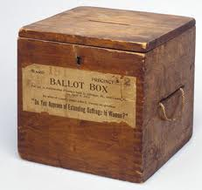Nominations for all positions close on the 29th Mar. If voting is req’d more detail will appear here or on the website as soon as advised. Please consider taking on a role to support the Club through season 21/22. Wish I knew more?

**Interesting Statistics**

In 2009-10 women BV affiliates in Metro. Region totalled 7093.

In 2009-10 men BV affiliates in Metro. Region totalled 14641.

In 2020-21 women BV affiliates in Metro. Region totalled 3737 (that’s a 47.31% drop in 11 years)

In 2020-21 men BV affiliates in Metro. Region totalled 10428 (that’s a 28.77% drop in 11 years)

**Winners of the Drinks** W/end. 6/3, Phil Westmore, Sally King, Barb Cheshire, Marika Forras (+9). 13/3, Rained off! (Bad luck Di. Cam. & Team +7)

M/week. 2/3, Jan Collins, John Paul, Robert Leitch, Deb Sherry +18.

9/3 Anne Kuuse, Barb Harrington, Bob Baird, Mary Weston +17. 16/3, Glen Baskett, John Paul, Robert Leitch, Deb Sherry +18 (again!)

**The 2020 Aust. Champ. of Champs will be played out at the Dandy Club on 24-25 Mar. ’21**. This event was cancelled a few times because of Covid. A great opportunity to catch some high performance players in action at the venue or via live streaming. For more info [Click Here](https://www.bowls.com.au/events-page/national-events/australian-champion-of-champions/)

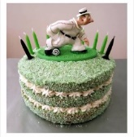**April Birthdays**

Pauline B. 18/4, Rod C. 8/4, John L. 14/4, Bill M. 20/4, Stephen P. 2/4, Cheryl P. 1/4, Suzanne W. 21/4, Mark O. 5/4.

**Mornington Peninsula Bowls - Women’s Post-Season Comp.** Following the success of the “Quick Chics” 2019 Women’s Only Pre-season competition, the Division are offering **a five-week season** at the end of pennant season 2020-21.

The greens are often at their best in Autumn, and the weather is often mild to warm.

**Format** - Sides of 6, run as two teams of three. Two bowl triples Played on Tuesday’s 10.30 am start. 2 games of 12 ends, with a lunch break. Novice and non-pennant players can participate alongside club members. **Dates** - Regular games will start on 20 April and the Final matches will be played on 25 May. Club entries ($20 entry fee per team to be invoiced by MPBR) close the first week of April with the Region’s Match Committee. Enquiries to John Adams - 0408034794.

The good thing about this event is that the Southern Peninsula Series includes our close Neighbours Carrum & Chelsea with the furthest venue being Mornington, and all rounds on the one day will be played at the one venue. So, Rd. 1 for instance “Carrum”.

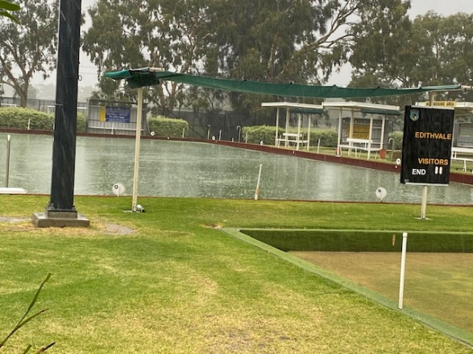**Weekend Pennant – Last Round 13th Mar ’21 – “A washout”.**

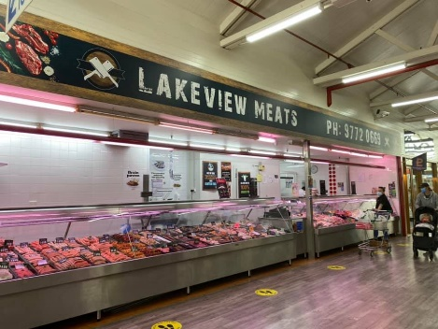The Div. 2 Side, finished bef. 2.50pm with 3 teams a Draw and Garry Byers’ Team, 4 Up. Div. 3 had 2 up and 2 down, Div. 5 had only 1 team up, Diane Cameron’s +7. The B.B.Q. after, was still a success, with most players returning from abandoned games by 4pm. The Gourmet Sausages (from Sponsors Lakeview Meats at Patterson Lakes), Onions and Bread were courtesy of John Bryant, Chair of Selection. Thanks John! All was prepared and ready for the returning players and for that we have to thank Glenys Gionis, Bernie Hambridge, Roger Williams, Trish Eastwood, Pauline Bourn

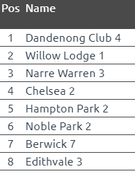 & Rosemary Grace. Thanks to Mary Weston, and Jimmy Brown for the clean-up and Andrew Tyrell on the bar.

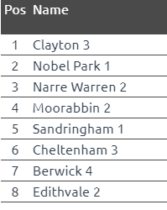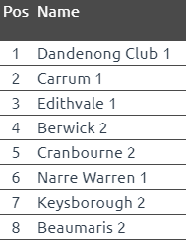Our First Side, Div. 2 Sect. 10, have scored themselves a Semi Final against Carrum at Carrum (3rd vs. 2nd at the 2nds home club.), while Berwick play Dandy Club at Dandy Club. (4th vs. 1st at the 1sts home club.). Only 1 Side goes up this year! If you are available, be at Carrum to support your Club Mates in their Sectional Semi Final.

**Midweek Pennant – Last Round 16th Mar ‘21**

The first Side won 65/46 for +19 and 14 points. The second Side had a practice,

and the third side won 70/47 for +23 and 16 points, almost clinching 4th spot on the ladder and a final. Alas Royal Melb at home put paid to that. The first and second Sides finished on top of the ladder and will host their Sectional Semi Finals at home, against Dandy Club and Chelsea resp., next Tuesday….. BE THERE!

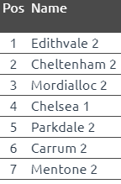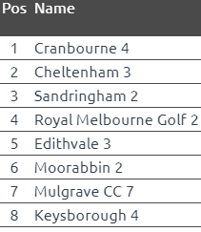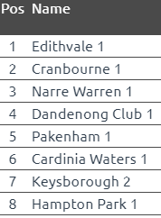

**Tuesday Night Pennant – Last round 9th Mar ‘21**

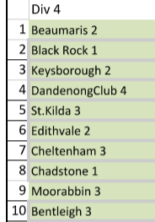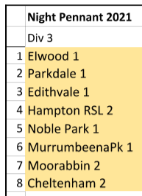Div. 3 made it to the Semi Final, and had to play Parkdale at Parkdale on Tue. 16th Mar. Div. 4 ended up mid-range at 6th almost in reach, with the no. of wins. Well done to all that played and those that filled in! Alas the Div. 3 side went down by 9 shots in the last few ends at Parkdale.

 **Baguley Carnival** Tournament Organiser, Ray Weston is keen to have your entry fees paid up front to ease stress on the day for the Match Committee. You can pay via the “black box” but make sure a record of your team players is provided at that time. Ray has prepared slips to accompany your payment with these details already recorded. We also need emergency players on standby for each day. This is very important, as, if a team pulls out and we don’t have a backup team, one of our own members teams will have to be pulled to even up the draw. Ray is still on the hunt for a team in both the Men’s and Mixed Triples. Dig deep, let’s make this Carnival our best.



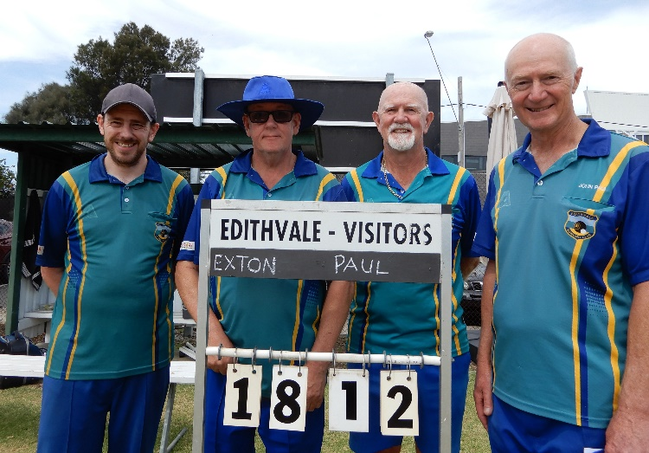The Men’s Club Championship Pairs on 5th Mar drew a crowd, keen to witness a brilliant display of precision bowling from Jason Exton/Bobby Semple and John Paul/Roger Selwood. They were not let down, as Jason Exton proved why he has been our Club Champ, 2 years running. The victors were 8 clear on the 17th end, but had to play an 18th. (Final score 18/12) The game was peppered with some breathtaking shots from all. Thanks Brendan for the keeping the scoreboard up to date. Umpire Pamela

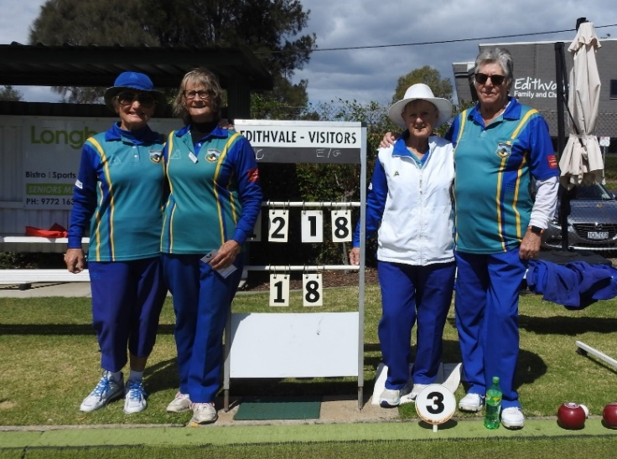The Ladies Club Championship Pairs on 14th Mar proved a tremendous tussle between Margaret Gumbleton/Trish Eastwood and Ann Pauligk/‘Tricia Comerford. (Final score 18/12.) The latter two held 2 or 3 shots on several ends after the score had reached 9/12 but had the tables turned on them with some beautifully weighted shots. A gripping game!

The Green was holding and the lines difficult to see, due to the heavy Saturday downpour. Thanks, Sallyann for keeping the scoreboard up to date. Umpire Suzanne.

**(DID someone mention the 1812 Overture?)**

**This Newsletter will be updated to include Finals results and Voting outcomes.**

**Henselite has new owners!**

Ian and Thomas Paterson have taken ownership of Henselite Bowls. The company was started in 1918 by William D. Hensell and post WW11 was managed by son Raymond W. Hensell. Ian will take on the role of Co. Chairman. Ian’s son, Thomas, will be the Henselite the Mgr. Dir.

Henselite, 103 years and counting!

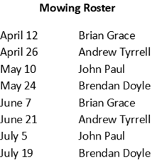



**Semi Final Div. 2 Sect. 10 Saturday 20th Mar ’21** Alas, we did not win! We fell short 66-89 with 3 ends to play. No need for Jason’s team to continue. Team results:

Rob Leitch 22-22, Jason Exton 17 -12, Garry Byers 13-26, Peter Woodbridge 14-29.

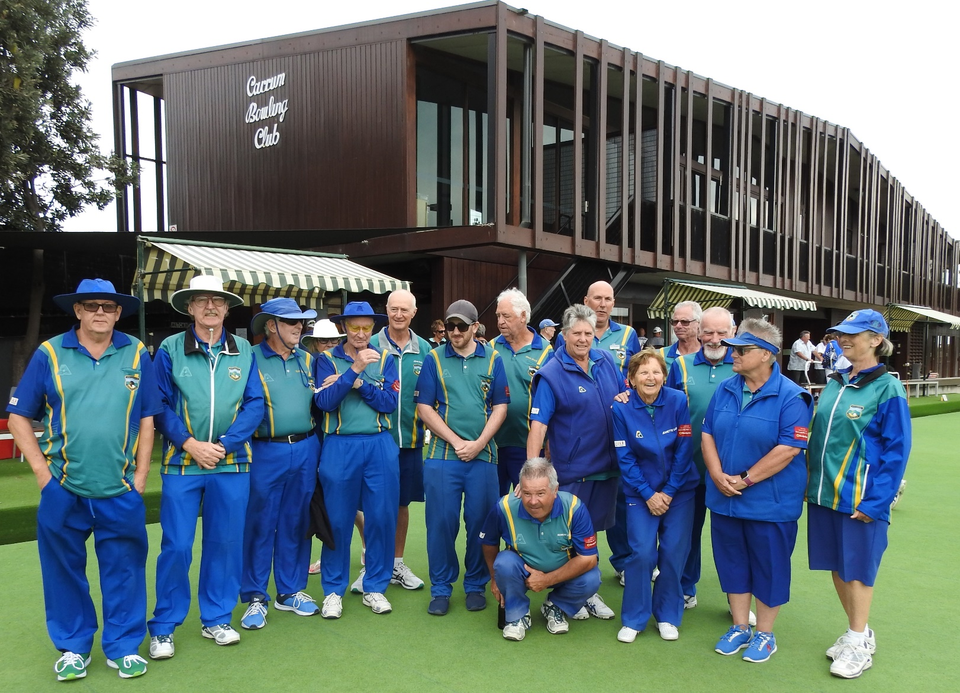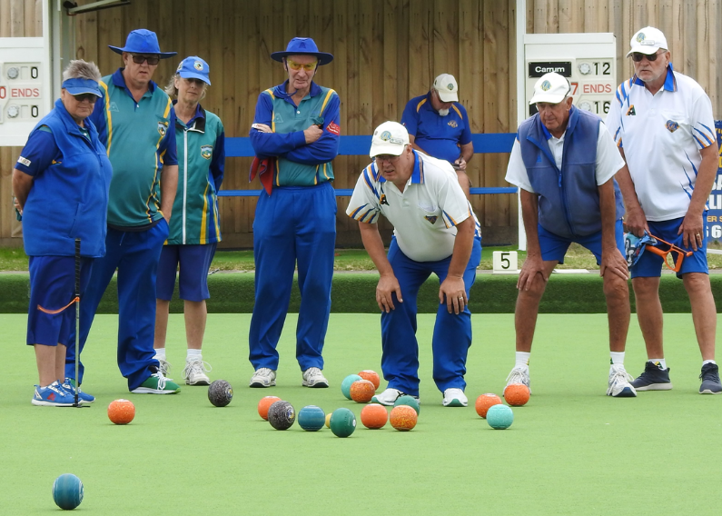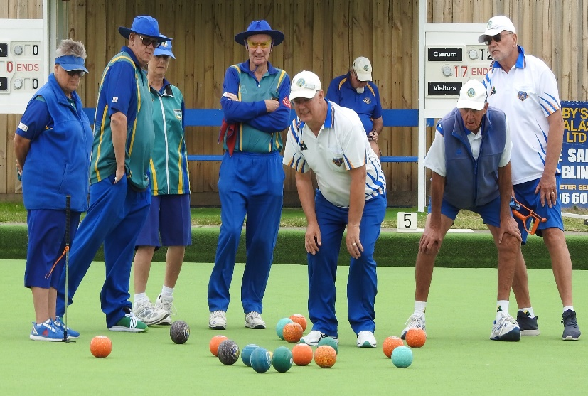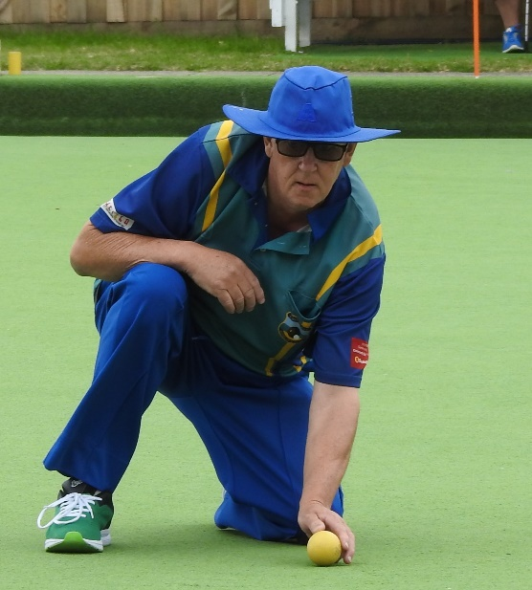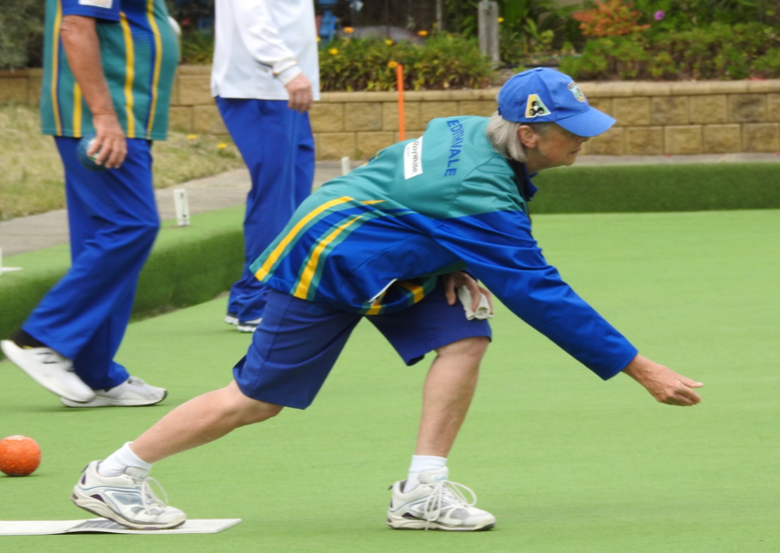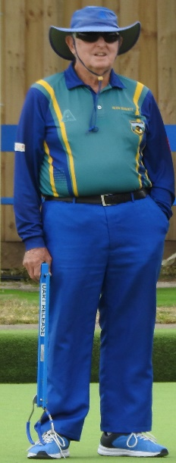

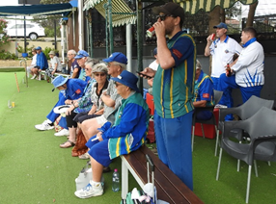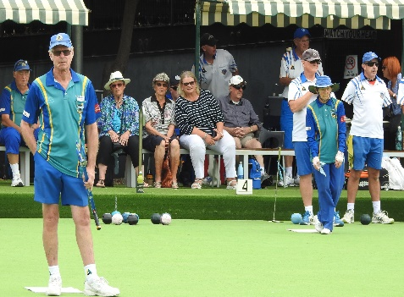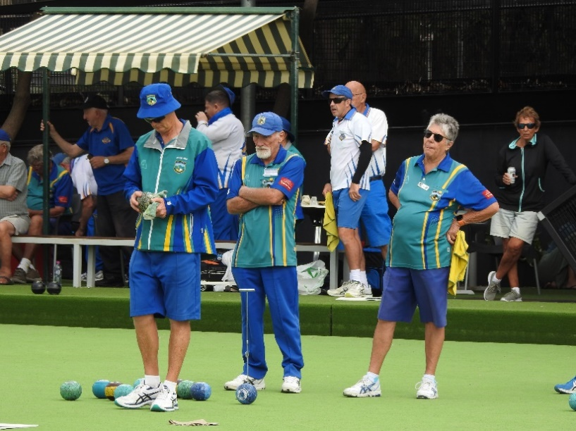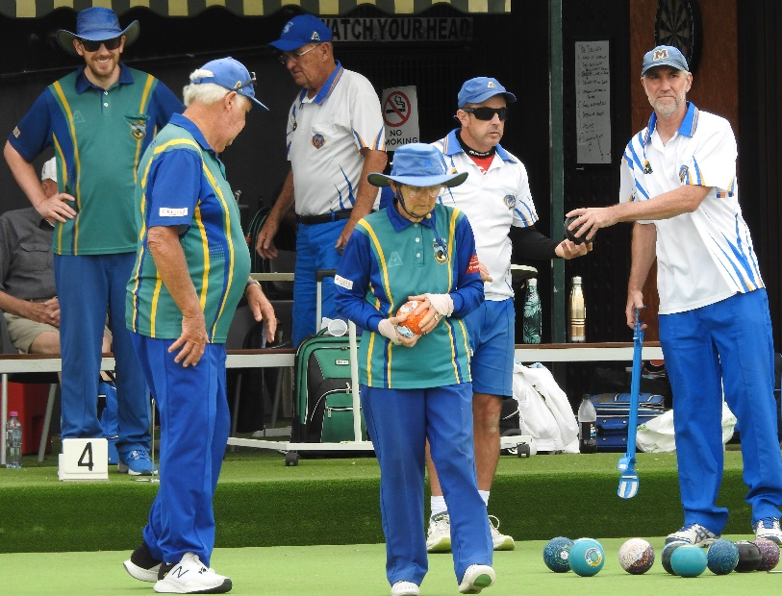

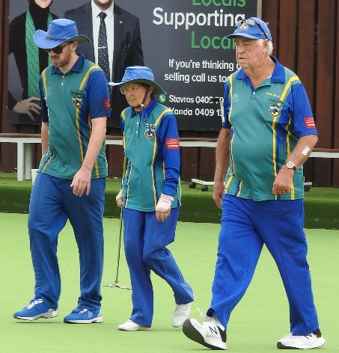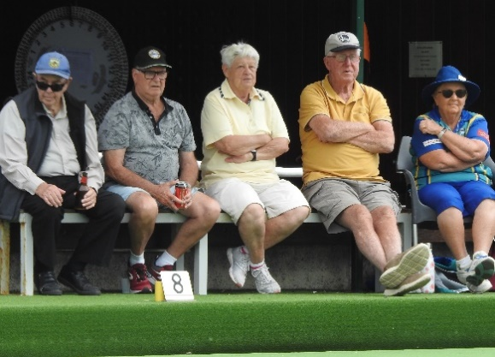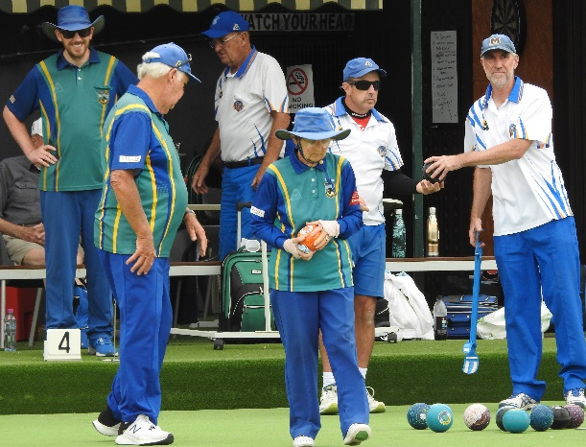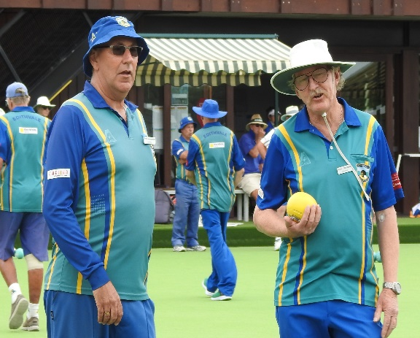

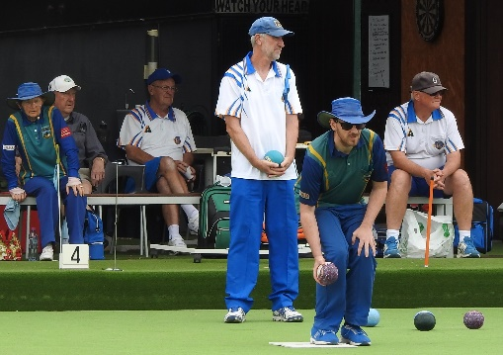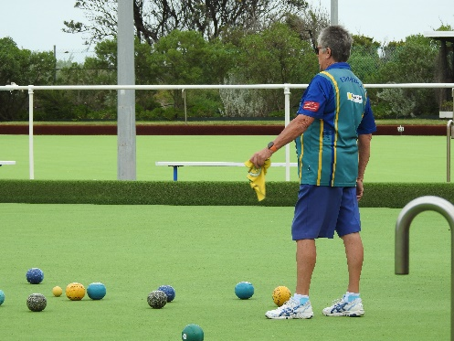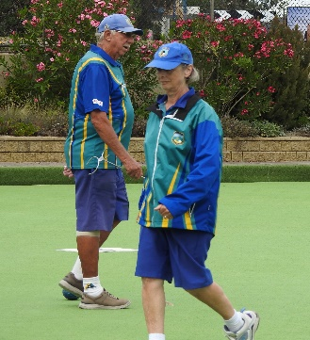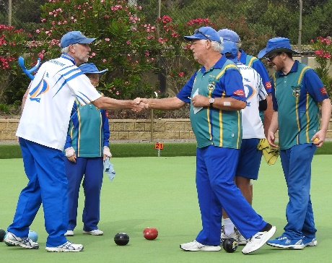

In the other Saturday Semi Final, D’nong Club def Berwick (104-65) at D’nong Club. On Sunday in the Div. 2 Sect. 10 Final, Carrum backed up defeating Dandenong Club (84-75) at Burden Park. Carrum now moves up to Div. 1.

This Newsletter will be updated again after Tuesdays Finals, but I doubt you’ll be able to open it ……. If you do…. Welcome! Cheers Pamela