Special Edition - Edi News – 23rd Mar ’21 – 8th Apr ’21 - M/week Sectional and Divisional Finals
Edithvale hosted two Sectional Semi Finals today because 2 of our 3 Sides finished “top of the ladder!” Our 3rd Side just missed out. Great result and Selectors should be proud.
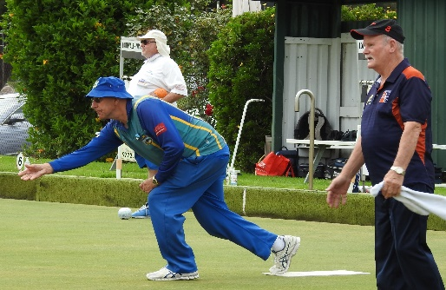
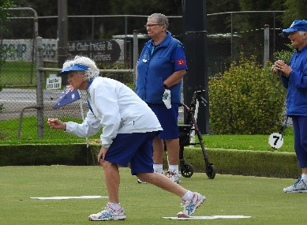
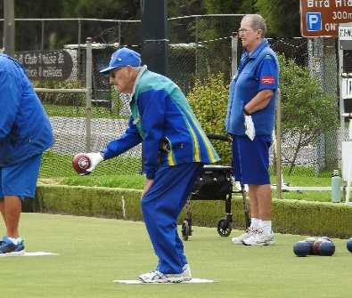
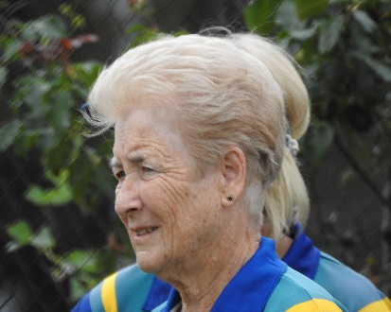
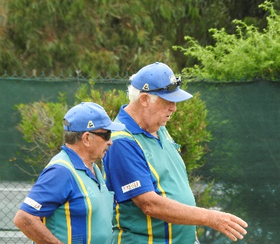
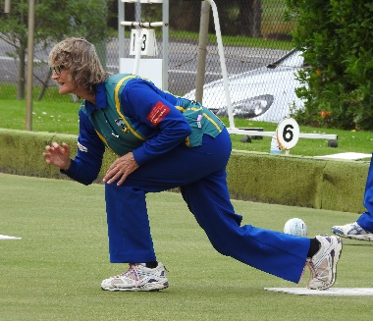
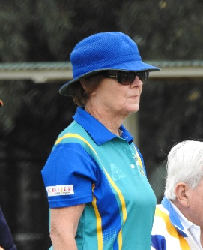
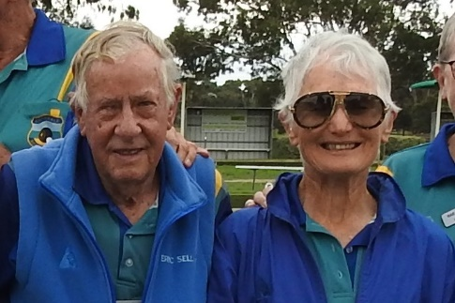
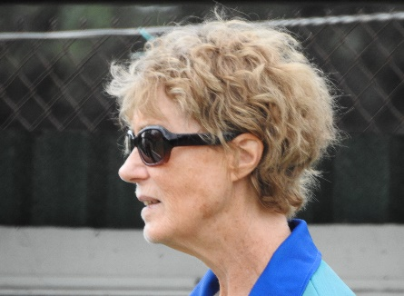
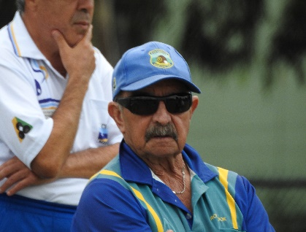
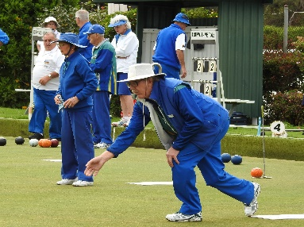
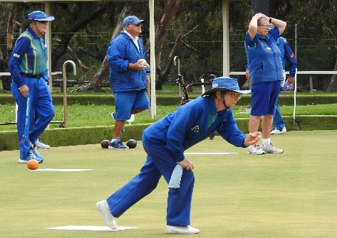
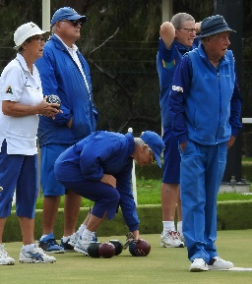
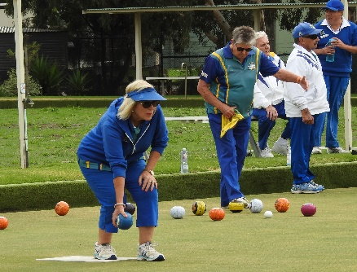
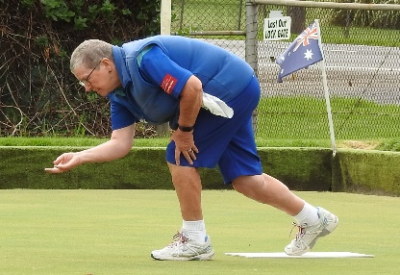
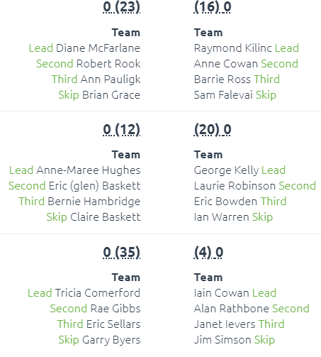
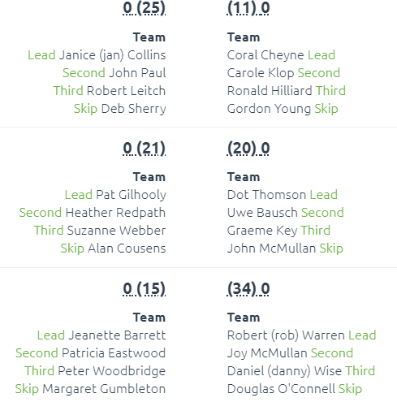

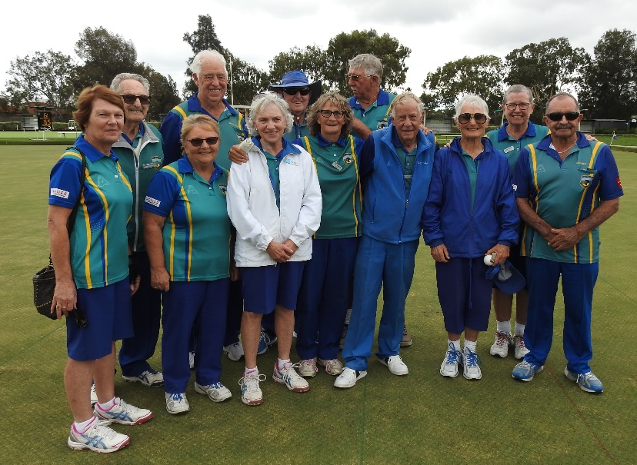
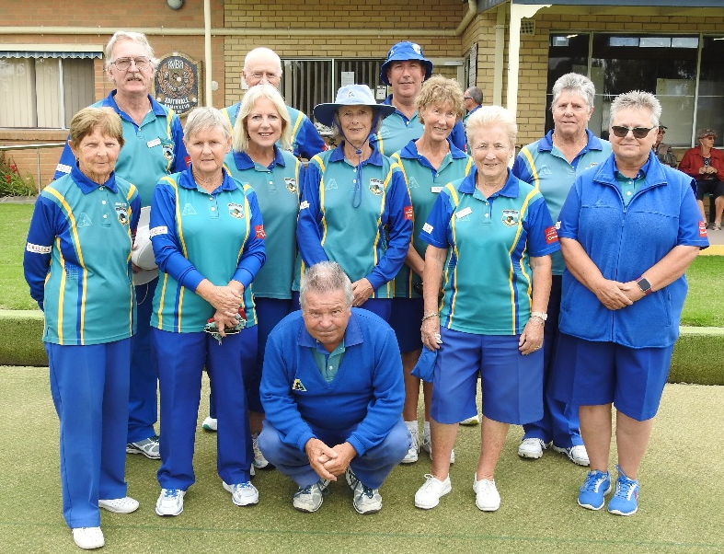
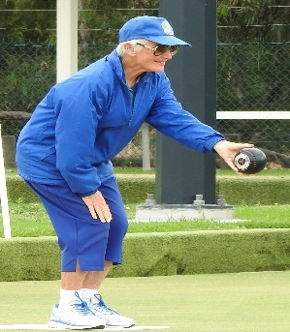
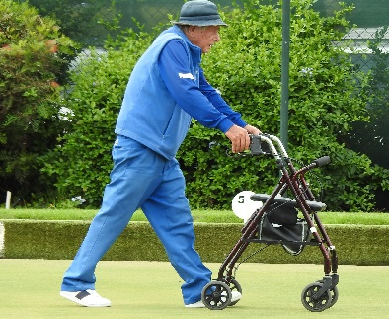
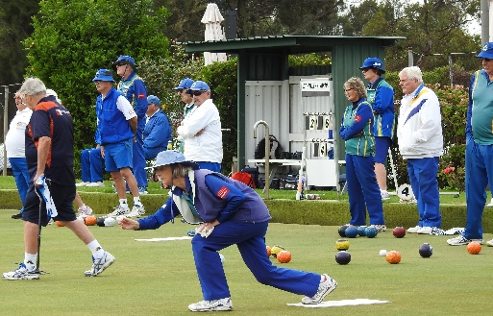
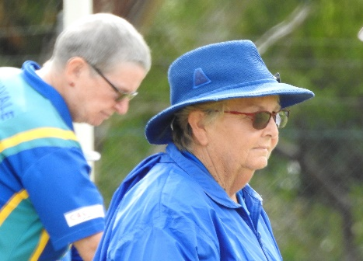
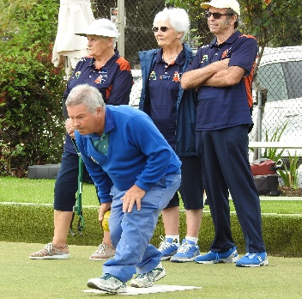
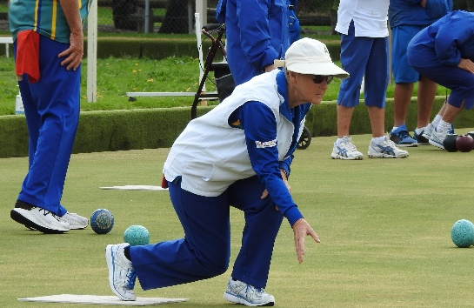
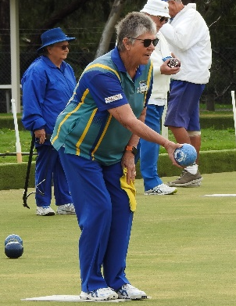
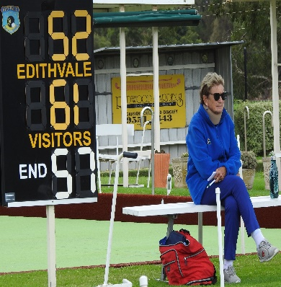
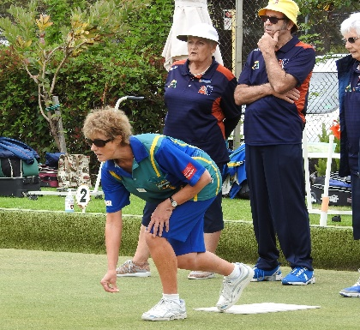
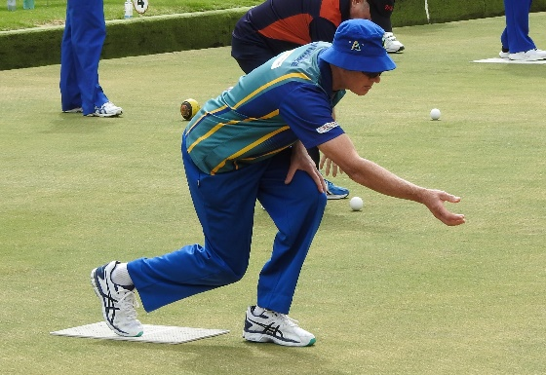
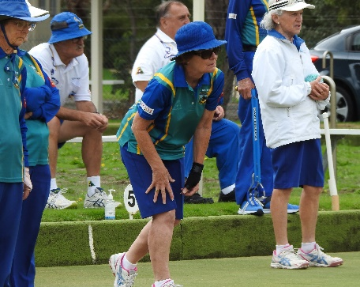
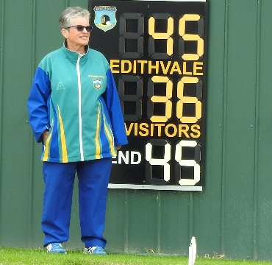
Good Luck to our Div. 3 Sect. 8 Side in the Final at Hampton B. C. on Thursday when they meet Cheltenham fresh off a 79-35 win at Cheltenham.
Div. 3 Sec. 8, Sectional Final at Hampton B. C. against Cheltenham (2) 25 Mar ‘21.
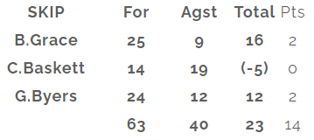
How fabulous was this Side today? After having been beaten by Chelt. 2, at our home on 9th Mar ’21 (38-64 and all rinks down), we came out today and pounced! Favourites today would have been Chelt. fresh off their “smashing” win against Mordialloc on Tuesday (75 – 39). Not to be………… “we whipped ‘em” 63-40 without Claire needing to play the last end. For Bernie Hambridge this was a happy and emotional day. Turning 92 in May and a member of Edithvale for 35 years, Bernie thinks this might be his first Sectional Final” win, even tho’ he remembers a few Semi’s. A great dependable, steady and consistent bowler. This day is yours to enjoy Bernie!
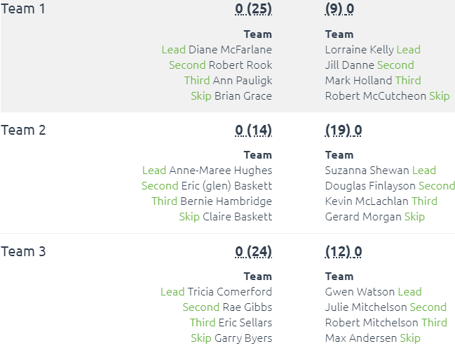
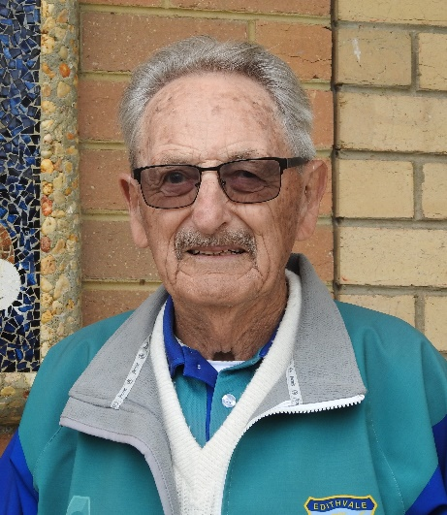

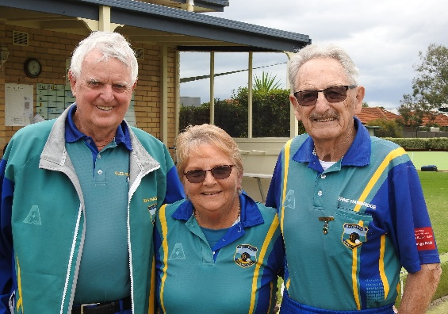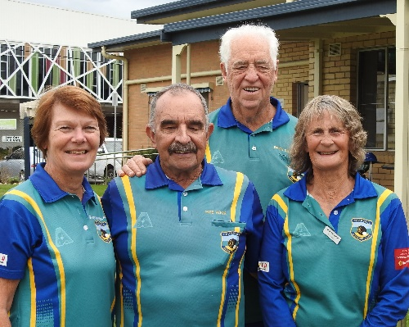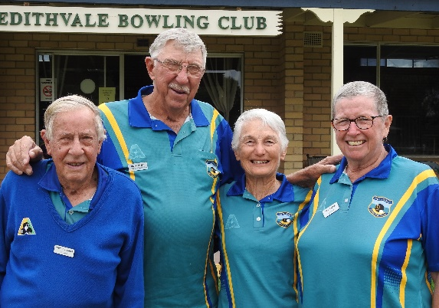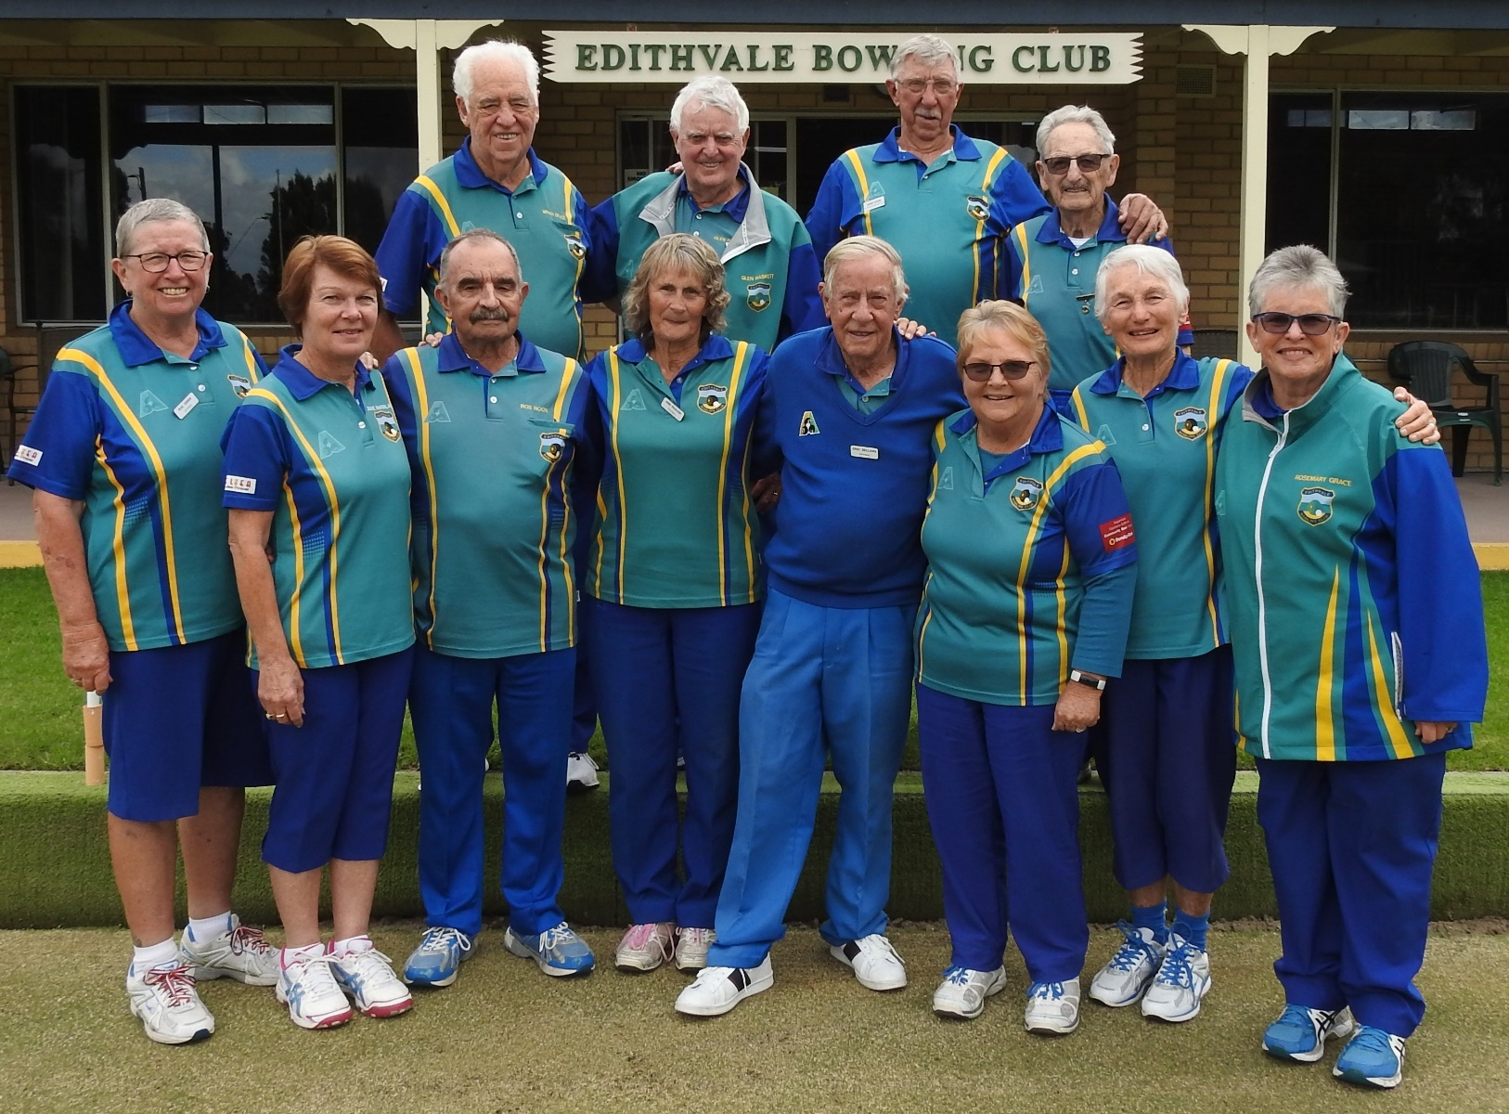
Quarter Finals Thursday 1 April ’21 (no Joke!)
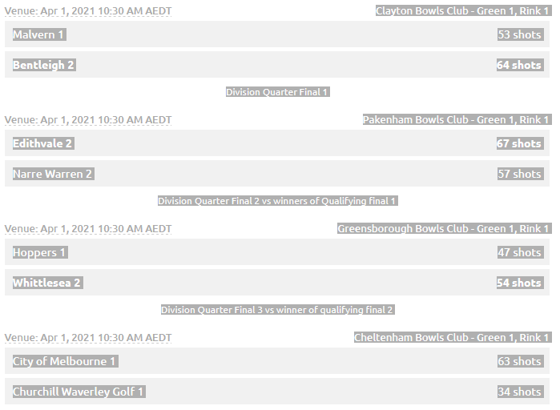
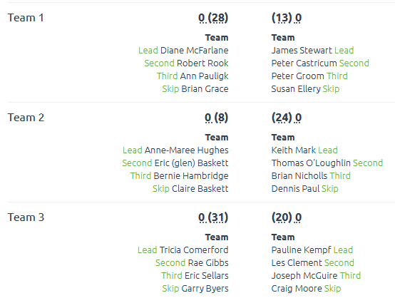
Edithvale 67 Vs. Narre Warren 57!
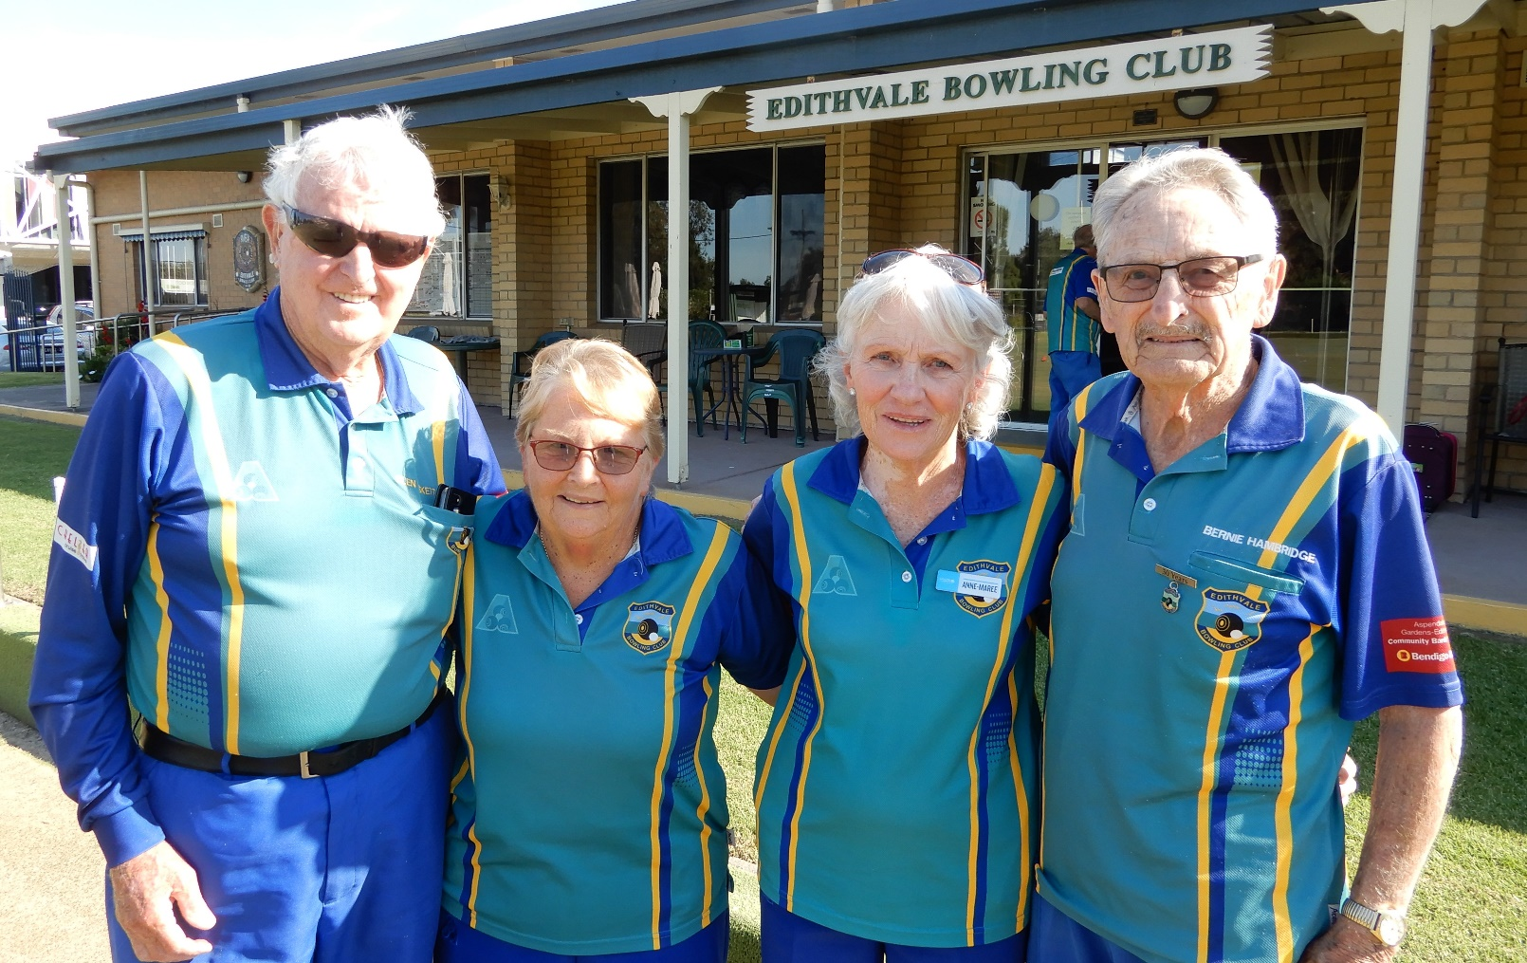
Well done Anne-marie (this photo for you, as you missed out last time).
Absent below Tricia Comerford and Robert Rook. Enjoy your dinner tonight!
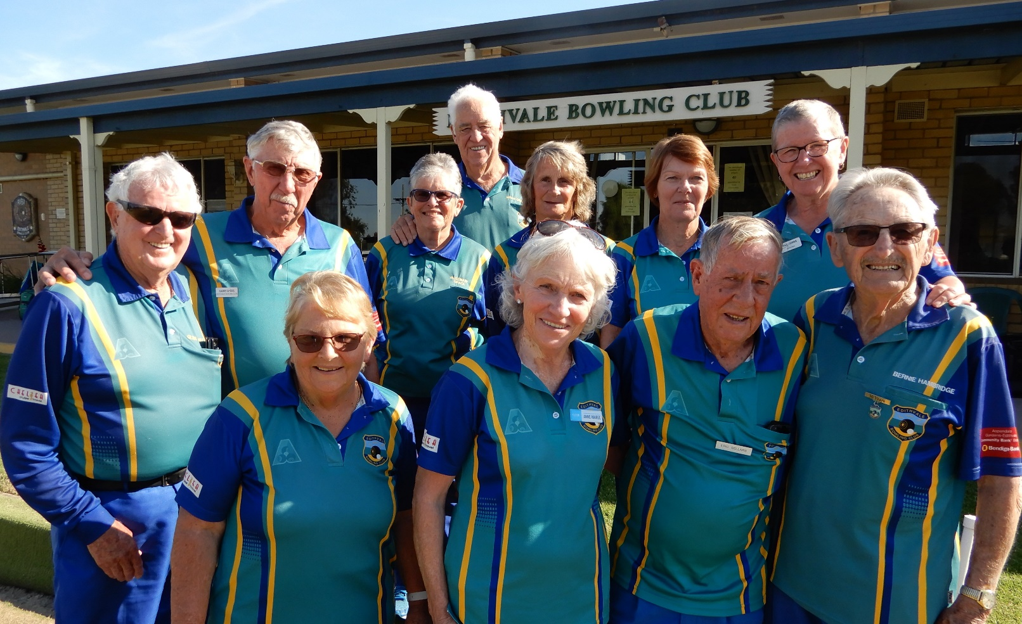
Division 3 Semi Final – Cheltenham – Tuesday 6th Apr ’21
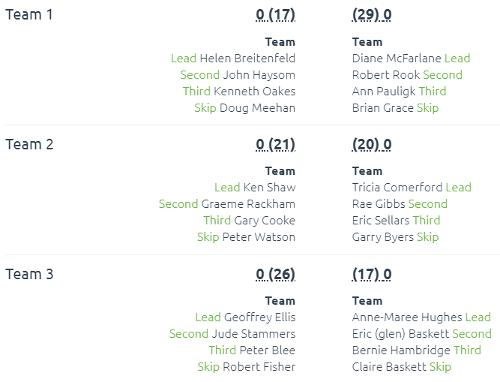
I can’t believe how today panned out! We were up at the break, then slumped, then came back, then dipped and back again AND with the scores 64-63 against us at 62 ends, with 5 bowls left to play on Claire’s rink, and down 3-4 shots (us needing 1 for a draw, 2 for a win) Bernie Hambridge dragged the jack with his last bowl making us 4 up!! The Bentleigh Skip took our 4th out, Claire played a block shot, the opposition Skip failed with his last after consultation with his third. The opposition Skip had had a personally brilliant day, but we had the 3 we needed w/o Claire having to play her last. How good is that! This was a Divisional Semi Final win, and now we go for the big one, at M. C. C. Bowls Club against City of Melbourne this Thursday. All Divisional finals will be at the MCC (Swinburne) venue.
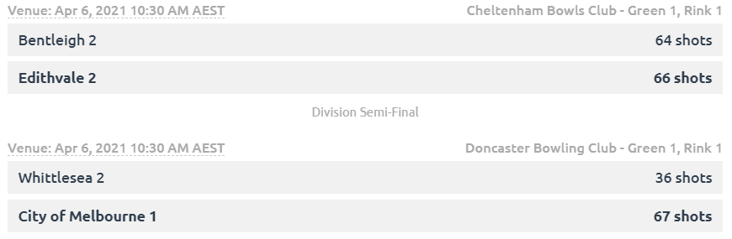

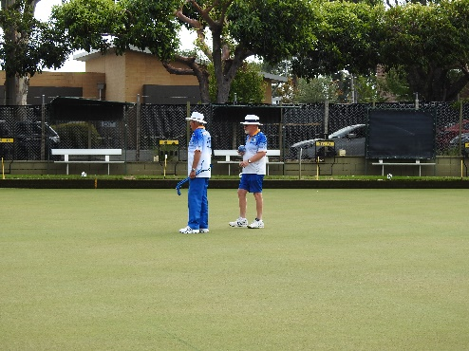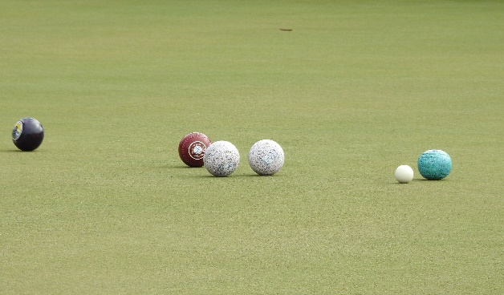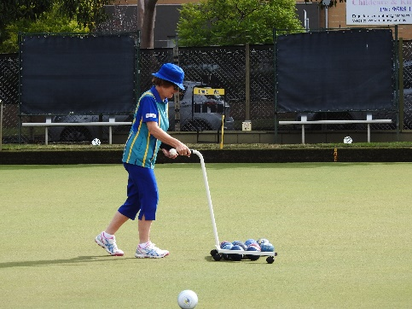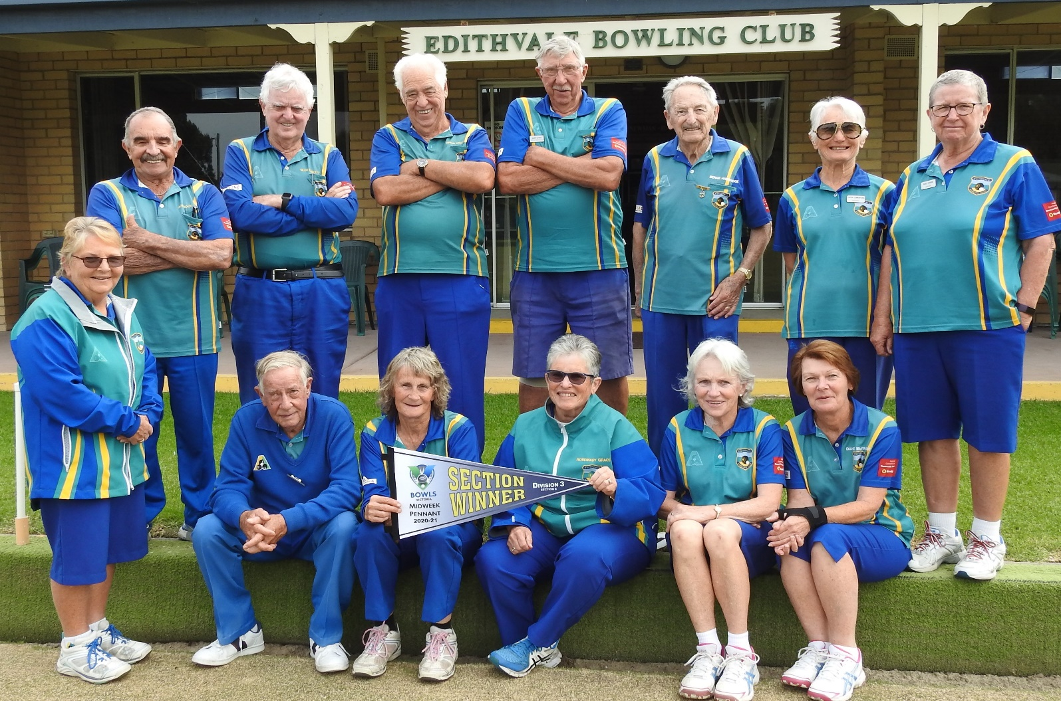
Equal Opportunity at work! 6 of each, on merit. WOW! Bentleigh had just 2 females a lead and second.
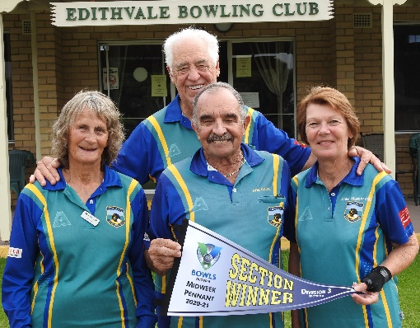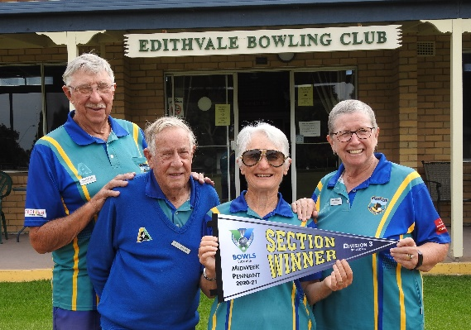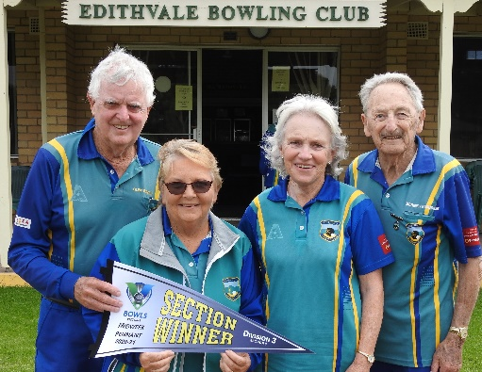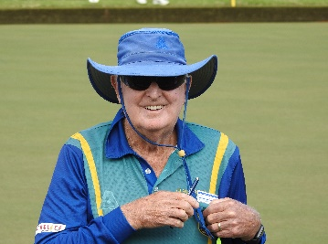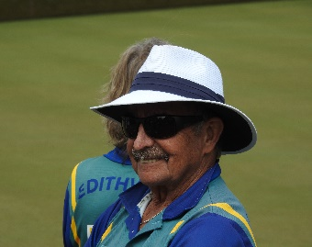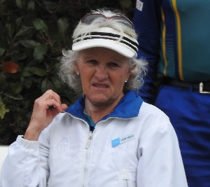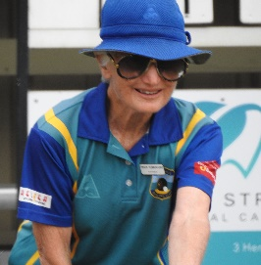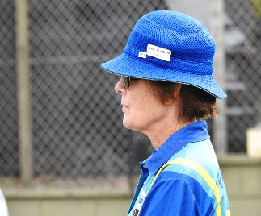
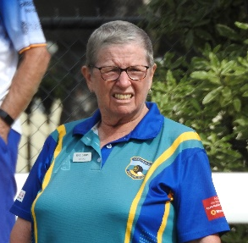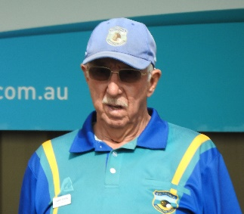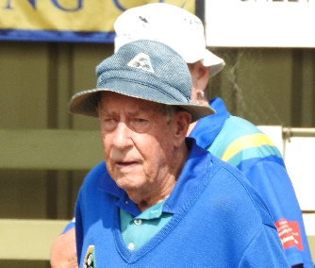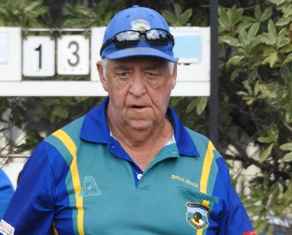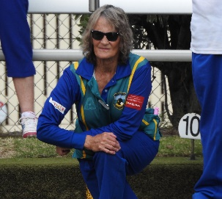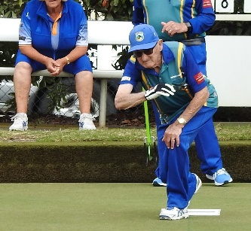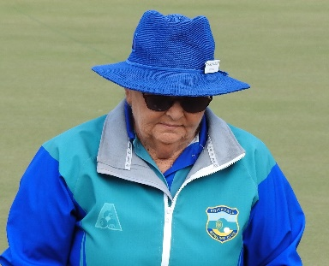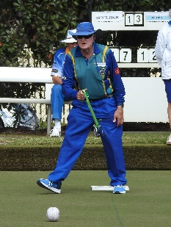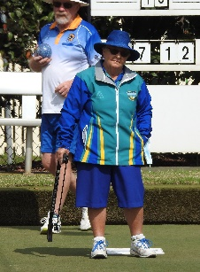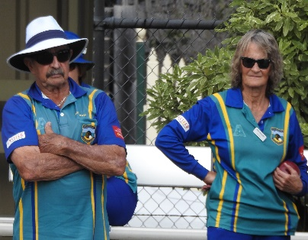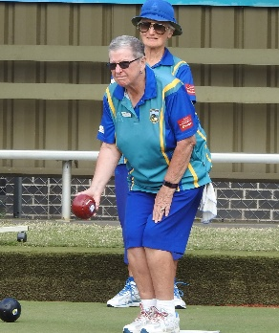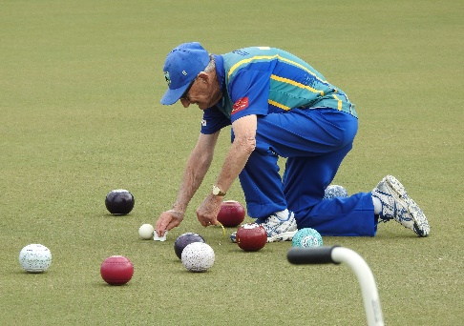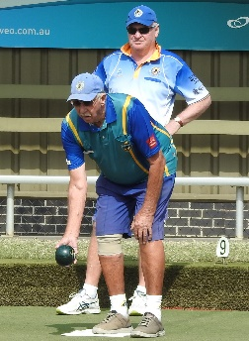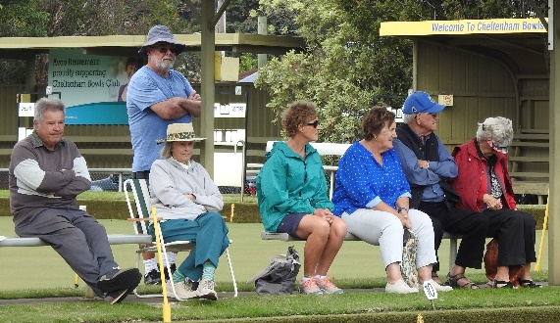
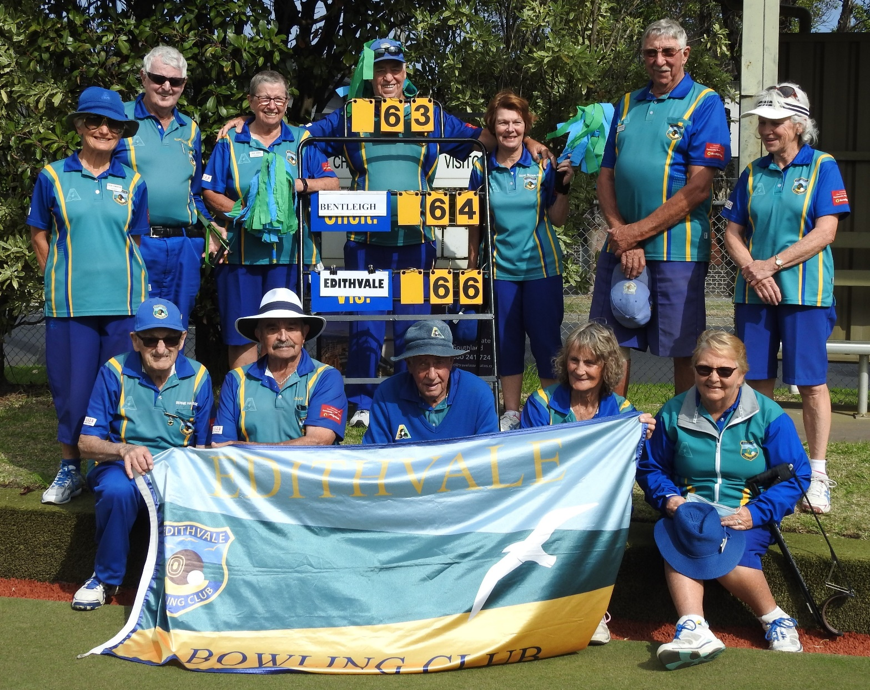
Next page Div. 3 Final
Below the Div. 3 Final, teams and scores from M. C. C. Bowls Edithvale (2) 57 lost to City of Melbourne (1) 70. Great effort!
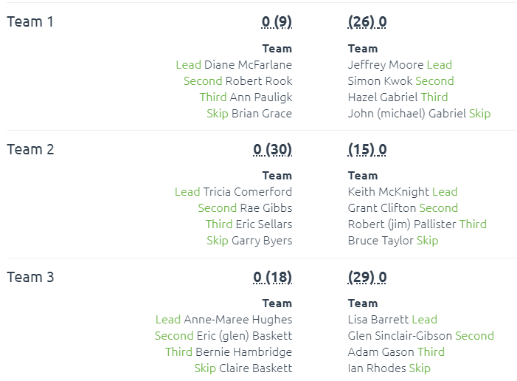
Garry Byers team of Tricia, Rae and Eric soundly beat the all-male team Skipped by Bruce Taylor, but alas Claire and team of Anne-Maree, Glen Baskett and Bernie Hambridge went down by 11 and the team of Brian Grace, Diane McFarlane, Robert Rook and Ann Pauligk went down by 17.
I can’t remember, off hand, how many times Edithvale may have reached this pinnacle, but I’m guessing in 52 yrs., not many. This Side should be very proud of itself, and they received a medal to confirm their achievement as Runner Up, Division 3 combatants 2021. (Once again the opposition had only 2 women, a third and a lead.) Very proud of my E.O. Club!
