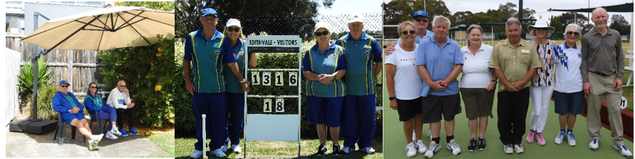
Newsletter 32. Feb-Mar ‘23
Congrats to our Mixed Pairs Championship Winners and Runners-up for 22-23. A brilliant game, well attended and played in great conditions. Winners Jimmy & Shellie Kavanagh (16). Runners up John Lyons & Heather Redpath (13).
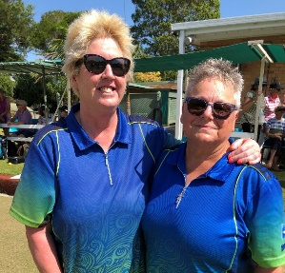
Congrats also to Deb & Claire Sandbelt Pairs Champs for 22-23 defeating D. Macaulay and A. McCarthy (15-13) on 22 Jan ‘23.
Social Bowls Thurs 9th Feb. Best last game, having lost their first (WoL), Peter Sale, Marg Rook & Roger Selwood. Winners of the Winners (WoW)were Ray Lambert, Anne Kuuse, Pamela & John Bryant, best first game was Richard Bull, Pat Gilhooly & Rosie Grace.
Thurs 16th Feb. Called off after 1 game when the outside temp. got to 36 degrees! WoL Peter Brain’s team, WoW Peter Woodbridge, Mary Weston & John Lyons, +11.
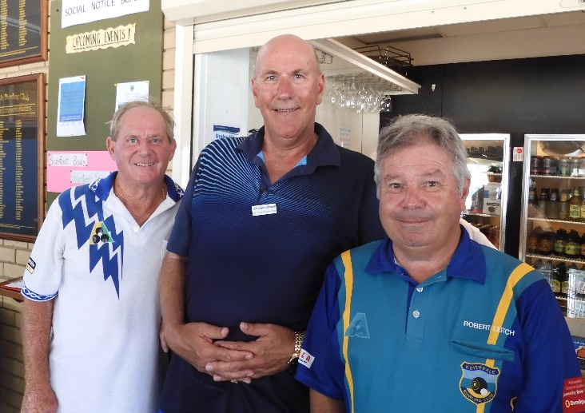
Thurs 23rd Feb. Predicted heat (33) was excelled and we stopped the 2nd game at 10 ends. A great day none the less with Bernie back to collect the wrong bias’s money. WoL Victor Marczenko, Norm Lewis (great effort, good to see you back and winning!) & Jan Collins. WoW Robert Leitch, Peter Woodbridge & John Lyons (did I hear them saying they got a 9?!). The choccies went to Ian Wilding, Bob Davies & Leila Hanna. Scratchies, and Bernie won something!! (Welcome back), so did Rosie & Peter Pawsey.
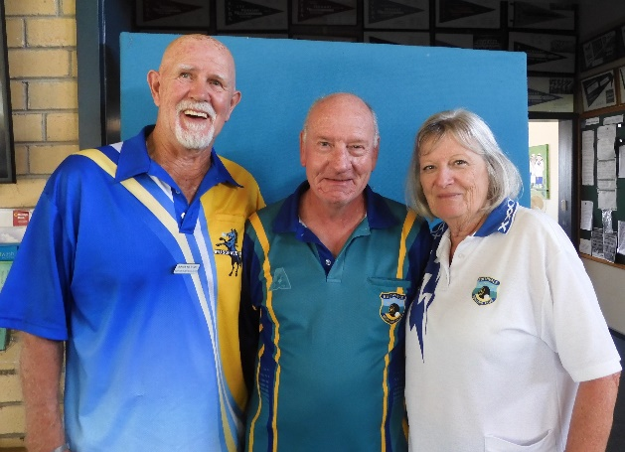
It’s farewell for now to Peter Sale. We sure are going to miss Pete but he assures us he will return in time for pennant season 2023-24. Stay well and travel safe.
CLICK HERE TO ENTER THE VIC OPEN.
Ladies Lunch Chelsea Heights Hotel Tuesday 7th Mar ’23.
Contact Mary Weston to reserve your seat.

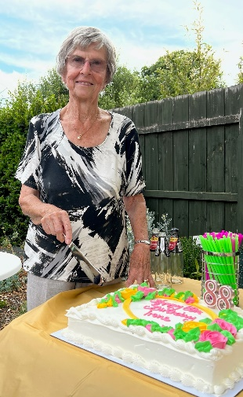
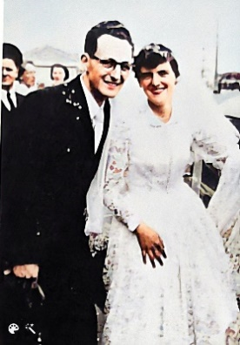
This lovely bride had her 90th birthday at our Club on Sun 12th Feb’23. You may recognise her chosen man? He’s been a member for 37 years. He saved us many a time on the greens, especially in a Sectional Final win at Cheltenham in 2021 with his amazing trail shot on the last end with Claire & Glen Baskett, turning a loss into a win! The lovely lady on the right celebrated her 88th birthday on 15th Feb ’23. Edithvale bowlers were invited to help celebrate as a “surprise” at her home. Her husband of 69 years, Walter, died last March. We hope to have Irene back on the greens soon.
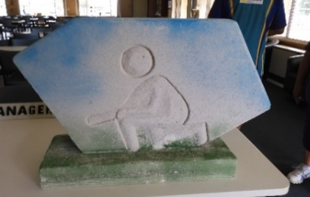
Someone left this “Objet D’art” at our front fence in February. The artist was J. D.W. and it was created in 2023. We are appreciative that it found it’s way to us and it is currently undergoing rejuvination by our very artistic Heather Redpath. Thank you to the artist, for passing it on to us!
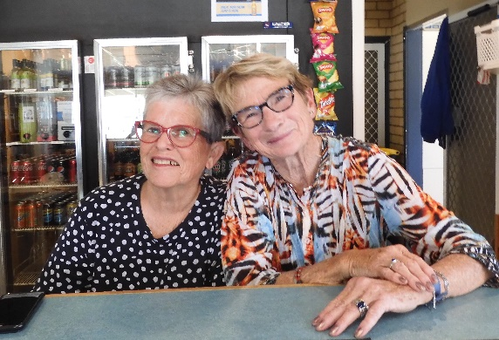
Thankyou to all the Bar workers, not just these two beauties but all who give of their time to serve us, restock and keep our bar profitable. Bar Manager Andrew Tyrrell, is assisted by Peter Brain, Barbara Cheshire, Alan Cousens, Brendan Doyle, Rosie Grace, Sallyann King, Robert Leitch, Peter Pawsey, Margaret Rook, Robert Rook, Roger Selwood, Barbara Sharp, Ian Thomas, R Weston & Peter Woodbridge. WoW, that’s a formidable list! Thank you all for your dedication.
March Birthday’s 2/3 Ron Young, 6/3 Jeffrey McLachlan, 9/3 Barb Dower, 10/3 Danny O’Brien & Bob Davies, 12/3 Ian Thomas, 15/3 Diane Cameron & Graeme Hewitt, 22/3 Rae Gibbs, 23/3 Glenys Gionis, 29/3 Brendan King.
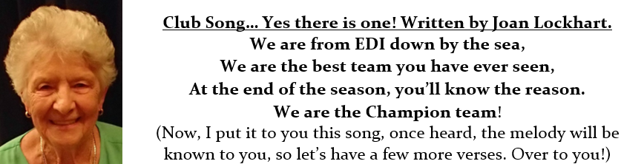
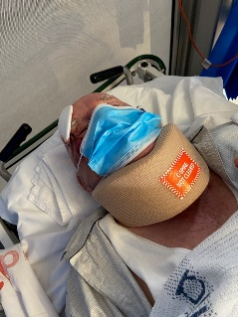
Sickies Bernie is back but he shares this photo with us, thanks Jan. (Be careful walking over speed humps!) Barbara Etheridge is looking good but still in a lot of pain, courtesy of “Shingles”. Have you had your injection yet?

Who am I? (Warning to would-be Selectors.) Thanks Stan Meale!
I'm a Number One Bowler, and a Prima Donna too,
And I won't be told, where to play, by blokes without a clue,
I'm simply just the greatest one to ever roll a bowl,
And when the pennant teams are picked, I want the starring role.
Now, the Chairman of Selectors, he said to ME one day,
We're gonna play you in the lead; like bloody hell I say,
Then later on he winked at me and very slyly beckoned,
There's been a change of plans he said, we're gonna play you second.
I let him know he's got a nerve, and said, "Now look here Bub,
If you can't appreciate my skill, I'll find another club".
So they hold a Special Meeting and pick me number three,
But I make it pretty plain to them, that's no bloody good to ME.
Another conference then takes place and after all the fun,
They put me where I should have been, a Skipper Number One.
I'm slightly mollified by now and though Skippers get the plums,
It's still beneath my dignity........to play with all you BUMS......
Thank you to all the Selection Committees who put up a valiant effort this Season.
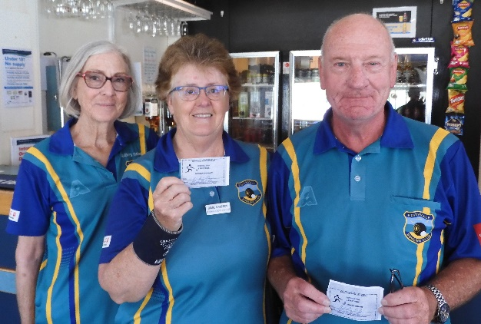
Tues Night Pennant 7th Feb ’23 Ray Weston, Sally King, Andrew Tyrrell & Craig Whatman had the best win, +19 against Black Rock at Sandringham. Ant Cameron, Peter Woodbridge, Marika Forras & Garry Dodge were next best at +13 while a third 2 shot win by Craig Jones, Rod Cameron, Shellie Kavanagh & Janienne Woodbridge gave this lot their highest score ever for night pennant since they started over 7 years ago. Well done to all players. They are now back on top of the ladder with Keysborough one shot behind. Tue 14th Feb was not so impressive as they suffered an 18 shot loss with only Antman Cameron, Diane Cameron, Garry Dodge & Col Buckley up 1 shot at C’ville. Tue 21st Feb., and it was Antman again, this time with Diane Cameron, Marika Forras & Colin Buckley, the only ones up again, snagging a SIX on the last end for a rink win by 3 shots.
Weekend Pennant Winners of the Drinks
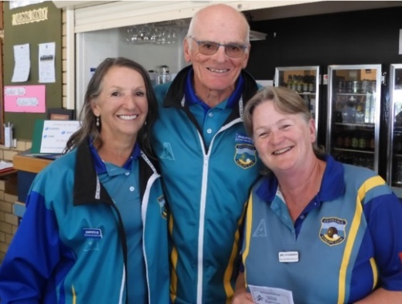
Glenys, Diane, Roger & Peter 38-8 Saturday Rd. 14 11th Feb '23 (Right), Cheryl, Jennifer, Shellie & Kingsley 33-14 Saturday Rd. 13 4th Feb ’23 (Left)
Weekend Pennant Divisions 2, 5 & 7 finished 3rd, 2nd & 5th on the ladder.
Our Div. 7 Side occupied 4th position all season until they were defeated and replaced by 5th on the ladder Cranbourne RSL(1) in Rd. 13. Altogether a wonderful result for the Club, with no Relegations.
Div. 2 lost to Mordialloc at Edithvale on the 18th Feb. in the Sect. Semi going down by 13 shots, Div. 5 lost to Narre Warren (4) at Narre Warren, minus 26 and having a second chance on 19th Feb., went down to Churchill Waverley Golf (1)
Midweek Pennant Divisions 2, 3 & 5 finished 4th, 7th & 6th on the ladder.
Division 2 was the only Side to play off in a Sect. Semi but lost to Parkdale at Parkdale. Ironically, they played them there on the previous Saturday in Rd. 14. Some relegations may happen with the other 2 sides, it’s a “wait and see”.
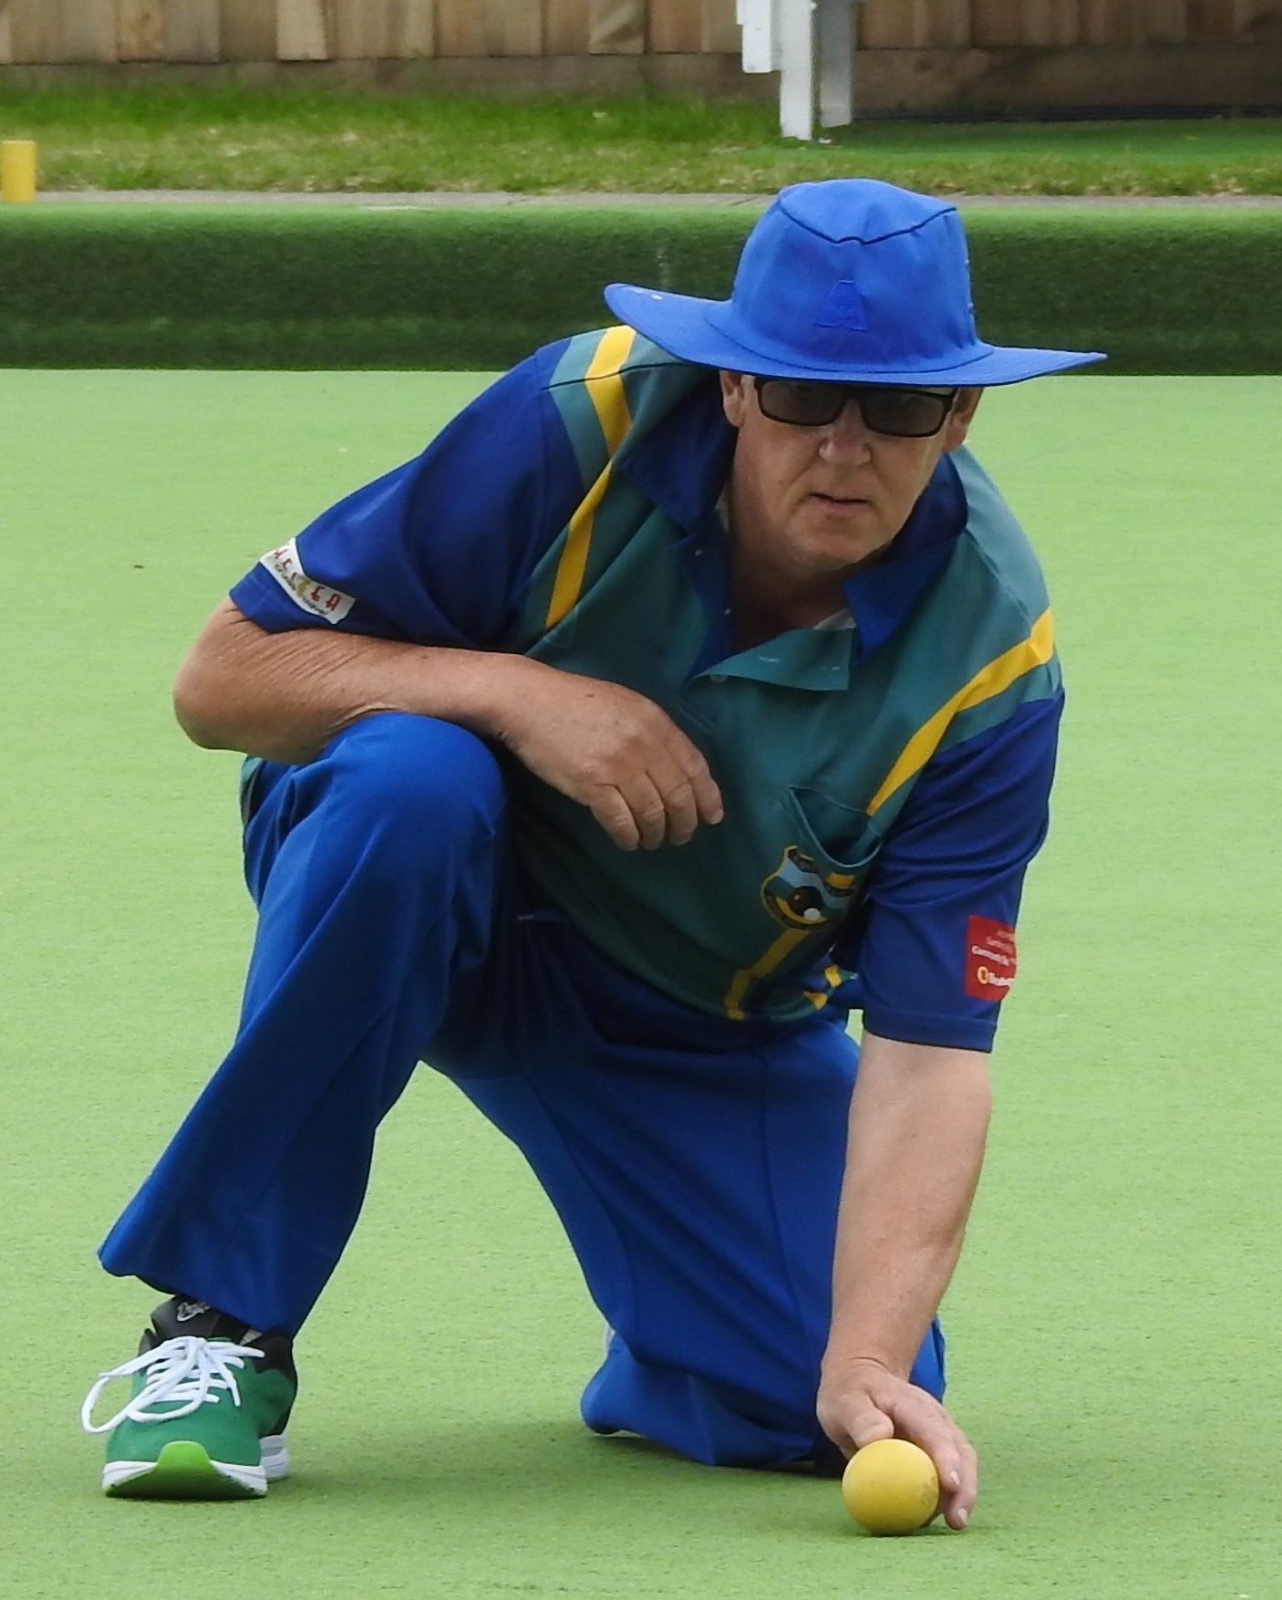

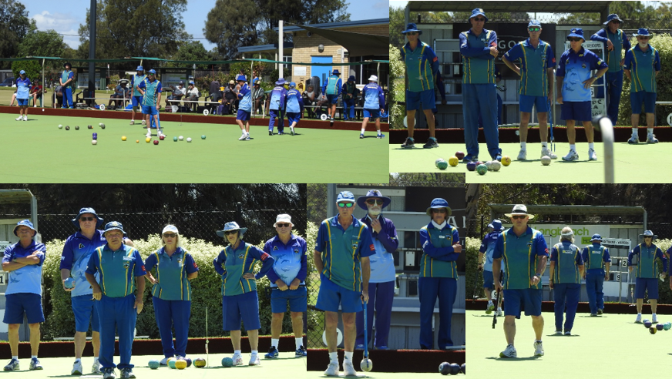
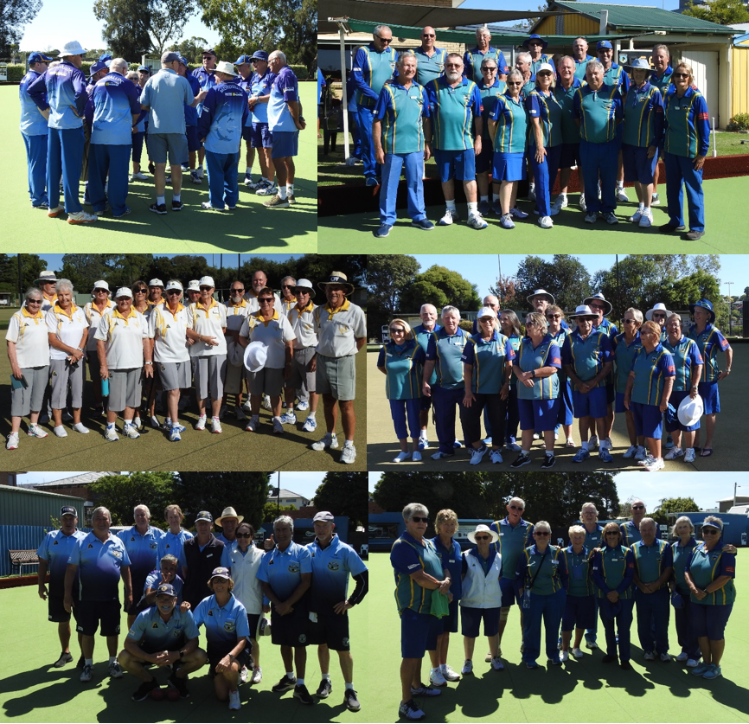
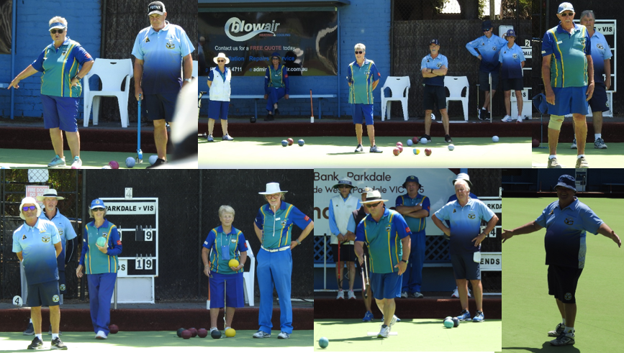
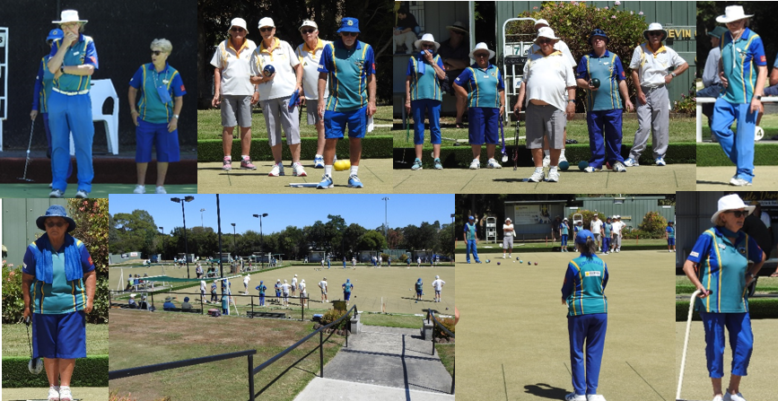
Tuesday Night Pennant finishes at Rd. 14 on 14th Mar ‘23
Barefoot Bowls is being extended to the end of March, if you can help out on these nights please contact Peter Woodbridge.
Tuesday Social bowls has started, 2 games of 10 ends, 11am start, BYOL, Mufti & Club Select.
The 1st monthly Twilight Bowls is on 4th Apr. ‘23
The AGM & Presentation Day is on 16th Apr ’23. Nominations req’d.

OOROO

