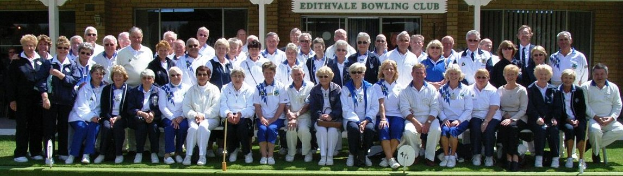
Newsletter 33. Mar – Apr ‘23
(Above a photo from our 40 year celebration.)
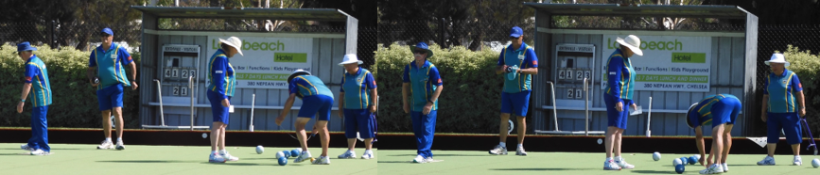
The “New Bowlers Tournament” was exciting to watch with some “Standout Bowling” from our newer members. Some had competed before, but for others, it was their first.
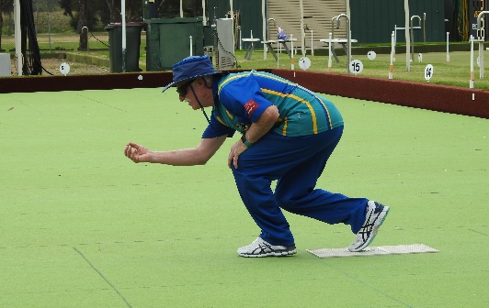
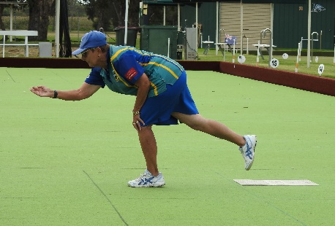
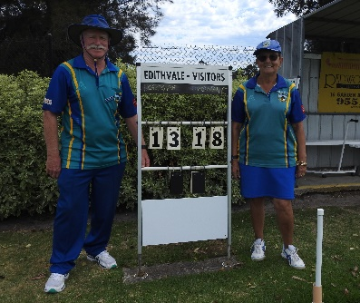
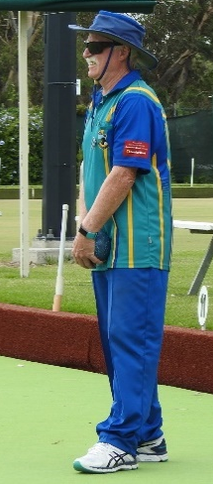
The final (18/3) was as good as any final you could wish for and the conditions, not far off the worst “wind wise”. LOL.
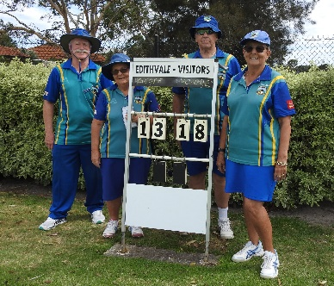
Jeff McLachlan shot out of the blocks scoring the first 2, Vonnie Ryan answered on the next end, scoring 2. Jeff picked up 3 singles over next three ends but was countered again by Vonnie’s 10 over the next four ends. That left the score 12-5 in Vonnie’s favour. Jeff then picked up 8 to Vonnie’s 3 over the next 5 ends. On their 17th end Vonnie picked up the 1 shot she had sought for the previous four ends, winning 18-13. A really fabulous game! Well done to both competitors.
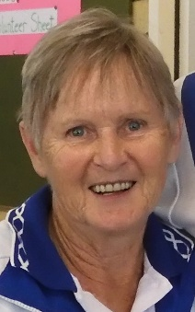
On the same day as the New Bowlers Pairs, our 2 Club Champions Trish Eastwood and Craig Jones, played off in the Sandbelt Regional Champion of Champions comp. Both performed well with Craig winning Rd. 2 25-8 but exiting in Rd. 3 in a close one 22-25 at Middle Park. Trish also had a close Rd. 1 going down 20-25 at Clayton to the eventual runner up Jessica Alvaro (Murrumbeena Park).
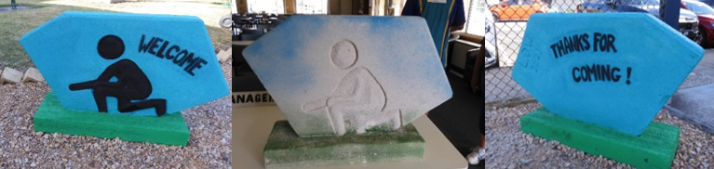
A big thank you to Heather Redpath on her restoration of some artwork, donated we guess, by artist J. D. W., produced in 2023. Left at our front gate it now welcomes all.
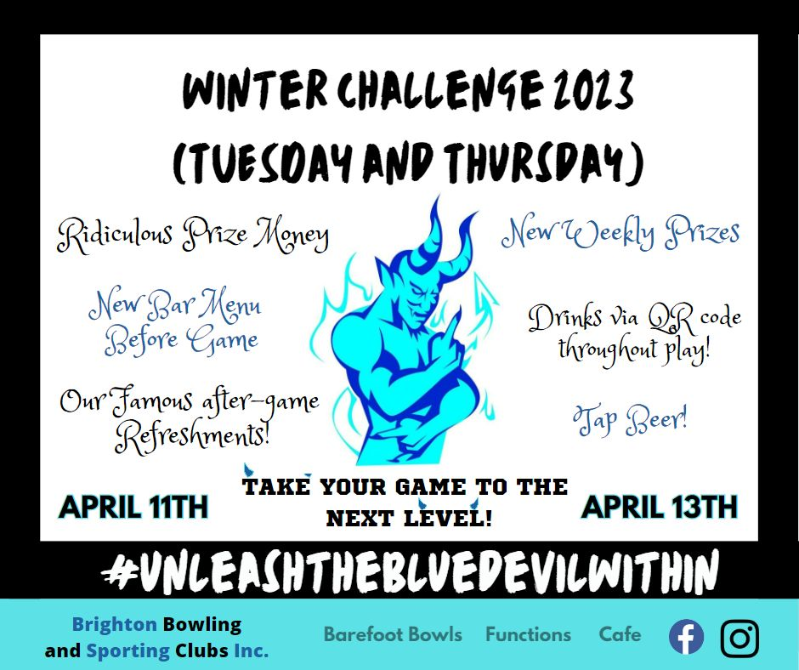
Brighton has the following events on in Mar. & Apr., if interested please contact Marika… and “please” get in quick for our own Gala Day!
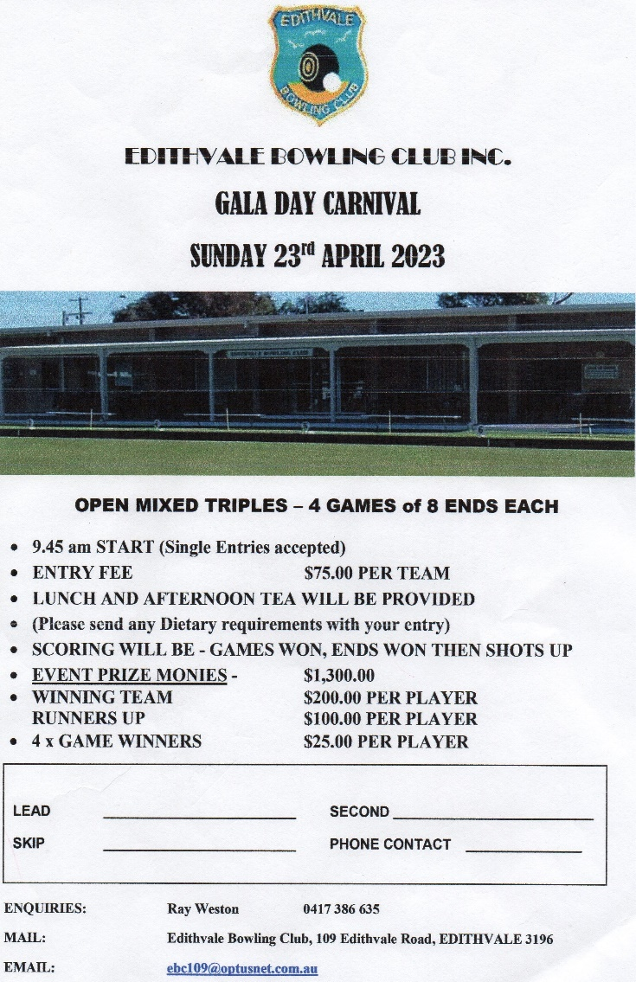

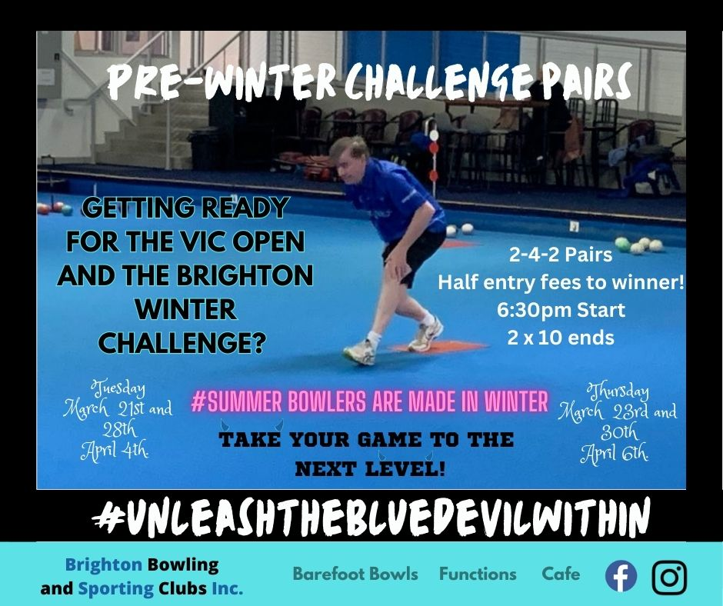

Happy April B’days to: Cheryl Plunkett 1/4 (no joke!), Stephen Pearson & Trish Eastwood 2/4, Mark Oswald 5/4, Rod Cameron 8/4, John Lyons 14/4, Pauline Bourn 18/4, Bill Morton 20/4, Suzanne Webber 21/4, Ken Arthur 26/4.

