Using a mechanical arm – by Pamela Bryant.
I’ve been a bowling tragic for 45 years. I’ve seen many changes over this time but without doubt the development of Bowling Arms from the wooden type on display at M. C. C. to the latest carbon fibre model has been the single most innovative development in our sport. Way above the constantly changing “perfect line” each “new” bowl promises to be. From now on when I say arm, I will usually be referring to “the aid” arm and measurements stated are rough estimates. Arms are key to opening up the sport to New Bowlers, who because of some, obvious or not, condition would never have considered bowls in the first place. Of course, thankfully, they also extend the bowling life of thousands of established bowlers who again, for some reason or another could not have continued and would have left the sport. (Indeed “we” wouldn’t be reading this today.) These people not only end their sporting life, but they also leave the Club, their circle of friends, acquaintances and relationships built up over many years. Their self-esteem also plummets. They may have been a valuable asset to the Club or to the Group. But now they are no longer a vital cog in our big happy community. Bowlers don’t leave Bowls to revisit their footy glory days, generally, they end their sporting and competitive life when they leave a bowling club. Can you imagine if we took all of the armed bowlers out of the sport how bereft the sport would be? The Arm is the one thing that keeps me in the game. I didn’t have a brain meltdown, and I can still read a head, direct a head, Coach, Umpire and play a valuable roll at my Club....it’s just I simply can’t get down anymore. My knees wore out but were never good from birth! There are many diverse conditions alleviated by the player having access to an arm, not just the obvious hips, backs and knees. (Consider: incontinence, diabetes instability, vertigo, neuropathies, shoulder, hand (carpal tunnel), neck conditions and many others.)
BUT you don’t need to prove yourself now!
Unfortunately, you’ll hear other bowlers saying things like “they shouldn’t be able to use that cheating stick”, “It’s unfair”, “they have an advantage”, “look at her, and she’s using a size 3-4 bowl!!!” What can I say ...? Yep, I see it as an advantage, and it takes away right hook, the left hook and the upward flick, or it should. It’s easier on your body; it enables you to front up 2-3 days running, instead of having to “lie up” for the next week after 1 Pennant Game! It enables a stronger more direct drive, and if you know how to find your “aiming line” then your halfway there. I got to improve rapidly after the uptake of the arm, (not better than I was … I’ve won many prestigious events, but I got back to where I was 5 years earlier) and I put that down to “getting my hunger back for the game” and with that hunger I got to do something that I couldn’t do for some years before the arm............I could practice again and not worry if I’d be able to walk or play tomorrow! The more I practiced the keener I got, so “the cheating stick” was only part of my resurgence. As for using a Size 3-4 .......the smaller bowls fell out! Arms were made to house a bowl from Size 3 up.
The “aiming line”, and I assume you already have well entrenched practices in finding your line? So now I’d like to ask you “how do you find yours?”
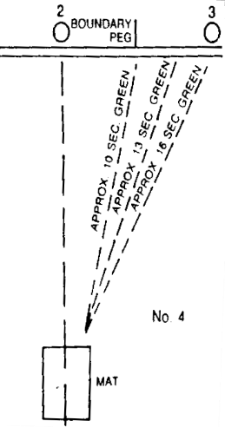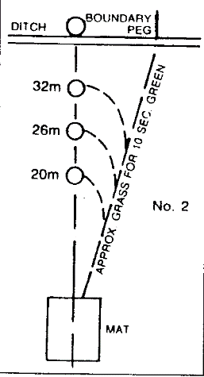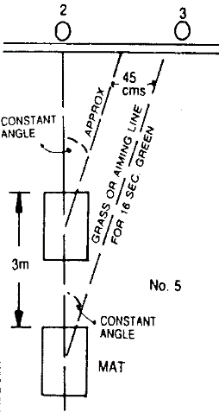
(Think Ratio, difficult isn’t it? Let’s say it is actually 45 centimetres for every 3 metres you move up the green! Can you recalculate every time someone moves the mat?) Sounds pretty tricky to me! Add to that the fact that all greens are not always the same width. Did you know they can be between 4.3 metres and 5.8 metres?
So, using the bank/pegs in the first instance and occasionally thereafter is a good thing, but knowing the line your bowl takes and the “Constant Angle” is probably more useful.
If you find you can’t use a close “point of focus” on your aiming line, when the jack is long, extend your view up the line and use your peripheral eyesight or memory to note the placement of the jack.
And I can’t stress that enough........ Its head down, body, shoulder and every other part, pointed at and to your “point of focus”! Hopefully, that’s not far up the green as looking “too far” up the green causes all sorts of problems, apart from the neck ache, it unbalances you, and it confuses your sub conscious. In particular it brings in the right hook, left hook and upward flick again!
You need to be looking down over your work, not chasing it halfway up the green. Not being “over your work” will unbalance you, challenge your momentum, cause you to miss your line and weight and frankly make you look a bit silly. In a game all about line, momentum and weight, getting the basics right is paramount. (I explain this paragraph further down.)
Now you know about the “aiming line”, the “constant angle”, and finding a “point of focus” let’s get the mechanics right!
Pick up the bowl from behind facing the direction chosen by the skip or yourself. (Wrong biases are quite common, always check when on the mat ). You can put the bowl between your feet and clamp it there ...............but I prefer to stand it up with my foot and adjust it in the cradle/jaws with my hand. I do that because I may have to do several adjustments to have it absolutely lined up with the rings and running surface......in sunlight, once on the mat! (It will look different sometimes when you are at the stance, and, to say “it’ll do” is not going to help you out.......you’ll be sorry you didn’t take the time for that final, precise line up.) Sometimes I do 2-3 adjustments!
Whatever has been your method of approaching your “aiming line” in the past does not need to change unless you are struggling with the concept of sticking to a line (remember you are now looking down on it, not up the green). Always approach the mat, directly facing your chosen line with your anchor foot (or stepping out foot, (if you follow the shooters stance) in tune with your aiming line, feet comfortably apart, with the weight on the balls of your feet (80%/20%) and your stepping out foot slightly in front.
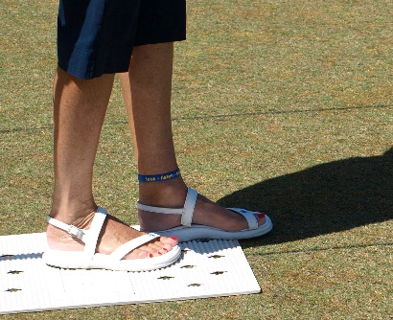
STANCE
Some of you may visualise the aiming line behind the mat which is OK. Some may visualise from the mat, that too, is also OK. I’m not teaching you to bowl, just to bowl with an arm. Whatever is your choice, once on the mat.......it’s “your” time! And you need to have “in your mind, the constant angle”. If the mat has moved and the spot you were visualising is no longer there ......it’s up to you to recall roughly how many feet/inches/cm that spot was from the centre line, or “imaginary” centre line.
A good tip is, to watch your opposition’s bowl at 8ft/2.5mt, and if it worked for them. Bingo! What happens to their bowl after the 1st 8 ft/2.5mt is of no interest, apart from of course, where it finished. Their line could reinforce your choice or add thought to it. If it’s “their” home green, it could be worth your while to take notice. Especially if you lose your way during a game.... look where their bowl goes 8ft/2.5mt out and of course you will have noted if they are left or right-handed and “where they stand on the mat”? The “type” of bowl they use at 8ft/2.5mt out really doesn’t matter as generally all bowls take the same green at that distance (scary isn’t it?). That’s using the “opposition” and their tools to your advantage. (Just as you would to see their favoured side of the rink.) This can also be done by observing the line a player takes at the other end of the green, noting how many feet/cm out from the centreline, their bowl is travelling.
The next challenge is Momentum = height + weight, even tho’ you are using an arm ...some things don’t change. It’s still a pendulum swing with height & speed but “without” the extended step. You should “never” NOT be over your work as I have explained before.
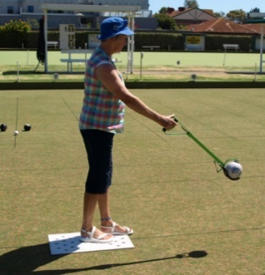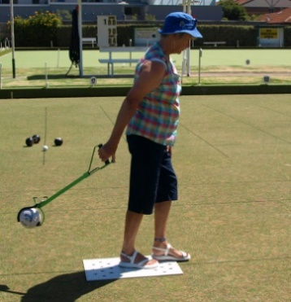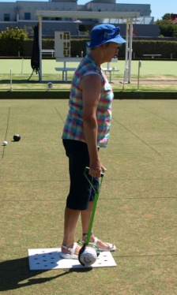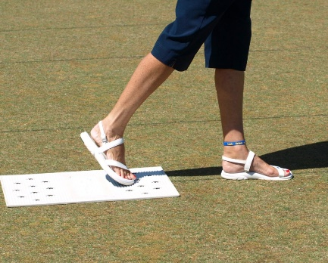
SWING, STEP, DELIVER, OBSERVE.
You don’t need a longer step; you already have a 2ft/60cm advantage in momentum with the arm. The same rules apply here as do with the “fleshy arm”; bend your elbow with an arm you lose 1ft/30cm, bend your wrist, Oopps there goes another 1ft/30cm. So:
- Straight arm, firm wrist and thumb!
- Practice swings to work out your speed/height, eyes on the point of focus, and peripherally on the jack. If the jack is too far up the green, I choose line over length, and persist with my “Point of Focus” (a point of focus which you can extend up the green) and maybe take a final glance. It’s important to remember here that “when in trouble” the only saviour is to draw your eyes back (!) and start again.
We should also be aware that as it is with a pendulum or a child’s swing there is a moment when you reach the end of your backward swing, that your arm needs a millisecond to adjust to the downhill forward motion, so remember “do not guide or force the forward motion, let gravity do that.” “Feel the Drop!”
They say you can’t teach weight...but I say you can. I can show you weight in a few seconds........but it’s the practice and learning that must be done by you. (Demonstrated)
So, .... we’re on the mat, there is nothing more crucial for an armed bowler “on the mat” than:
- A stabilised stationary hand. (The one without the bowl!)
- A relaxed bowling hand, trigger finger, or palm on release! and
- An empty head. (We all get chatter...some more than most), but chatter is of no use here & now! (‘tis better to stare, vacantly at your point of focus, than to try and run through a “to do” list at this stage, the horse has bolted ....it is too late!)
These last 2 things are indeed crucial “Relaxed Hand and Clear Mind!!!”
(To relax your hand on release, release on the “exhale” as this un-jangles the nerve endings (our grunting tennis players may be right?).
We are ready to bowl, we’ve visualised, we are relaxed, our bowl is perfectly straight in the cradle and the running surface is aimed at your point of focus. Indeed, every part of your body, shoulders and eyes are all squarely aimed at your “point of focus”. A few practice swings are now required, remembering 80% of your body weight should be over your anchor foot and 20% on your stepping out foot. Don’t rush it, work to the height and speed required and when ready, step forward as the bowl reaches its lowest point, and release as your step completes. Body weight should “transfer” from your anchor foot to your stepping out foot with no discernible change in body weight distribution and little or no upper body inclination until the bowl has been safely delivered. Your arm should follow through so you can see the bowl traverse your point of focus and your eyes should “stay with the bowl until it finishes”, thus drawing a picture for your sub conscious.
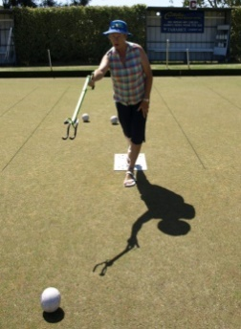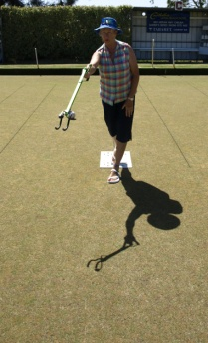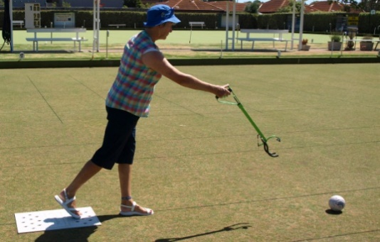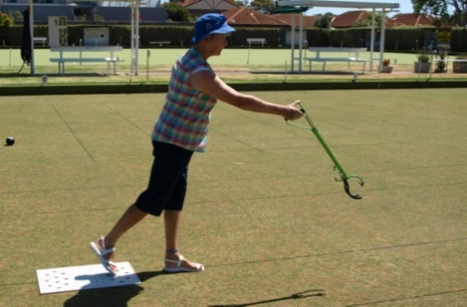
FOLLOW THROUGH
Whenever you practice, and I bet you can’t wait to start now, start with short ends to get your feel and focus activated. I hope you have enjoyed this session. Let’s get some bowls happening!
Remains the property of Pamela Bryant, but can be used with acknowledgement, and unchanged.
pamelabryant@bigpond.com
Post note: from the 1 May ’19 you do not need to have a medical certificate to use an arm! Arms must be of registered/accepted design and once picked up in a game must be used for the rest of the game (jack excluded).
11 Points to note
Ensure bowl is housed so that it will travel on the centre running surface.
- Approach the mat, in the direction you will play visualizing the aiming line, jack high.
- Visualize halfway between jack high and mat. (Helps with weight/shoulder)
- Find a point of focus 8-10 out. From here on, stick to your chosen constant angle.
- Check your feet, place weight on the balls of your feet, 80% on the stationary, 20% on the stepping out foot, knees relaxed.
- Stabilize your non-bowling hand. (Put it in your pocket!)
- Do a practice swing or two, to feel the weight of the bowl, with arm & wrist firm but not tight.
- Hold the bowl with the minimum of stress. (Especially the hacksaw.)
- Taking a SHORT step, release the bowl at 6 o’clock, on the exhale, beside your stepping out foot. Heal on stepping out foot no further than a few inches in front of mat.
- Make sure you remain upright, no slouched shoulder, looking at your point of focus.
- Stationary foot to remain on mat, roll up to toe.
(Teaching Weight) The first thing I would do if I were with you, would be to stand 2 metres away from you with a bean bag in my hand and throw it to you, underarm. You would throw it back, then we would both take a step back and I’d throw it again. We would each step back again after each throw. You would notice that you need more speed and more backswing the further apart we got. At the back of the swing, there is a milli-second when you and the bean bag decide it’s time to go forward. (This is where the Pendulum Swing comes in!) After all a clock doesn’t go “tick, tock” really quickly, it goes Tick AND Tock and a swing goes Up AND Down….. we don’t want to be a pusher, do we?
So, when using the arm, apply similar logic. I can’t stress enough…. You have to FEEL the drop. Don’t push it.
That’s my theory anyway, and it’s served me well. (The last time I entered the Vic. Armed Singles and Pairs (2019)
I won both!). Something must have been working, and I hope it works for you.

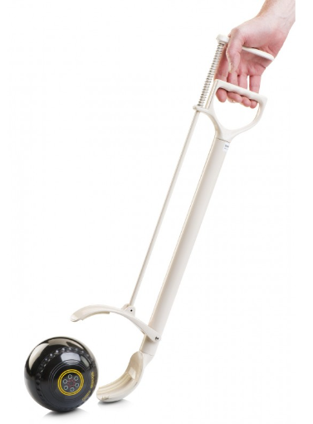
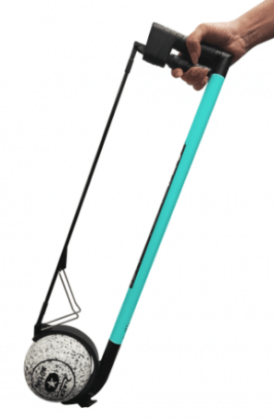
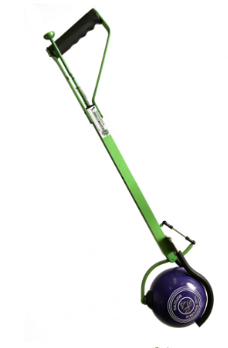
In order “The Bionic”, “The DHB (Hacksaw)” and “Drakes Pride”.
Ideally clearance, cup to ground, roughly, 4 inches (100 MM) to save your back. Have a few practice swings to see what suits you. Good luck and good bowling!
Cheers Pamela Bryant.

Shooters Stance Pt 1 & 2 – By Neville Rodda - my preferred stance.
https://www.youtube.com/watch?v=3b9cKvPeWj4
https://www.youtube.com/watch?v=UkKgJWDq1GA
Using an arm by David Bernard and Clayton Parker
https://www.facebook.com/watch/?v=824516588091354
https://www.facebook.com/clayton.parker.739/videos/999950170541389/

Explanation of “You need to be looking down over your work, not chasing it halfway up the green. Not being “over your work” will unbalance you, challenge your momentum, cause you to miss your line and weight and frankly make you look a bit silly. In a game all about line, momentum and weight, getting the basics right is paramount.
It reiterates the “deliver at 6 o’clock” after a short step. Some people reach out (maybe their arm is too short) and deliver way out front which means the bottom of the cradle is already pointing up causing the bowl to be dumped from a height, not rolled, and the player looking more like a flamenco dancer than a bowler with the arm ending almost head height. They usually end up running off the mat instead of just rolling up on their stationary foot toes. My point of focus is 10 to 12 feet in front. I need to see (my subconscious needs to know) where my bowl rolled in relation to that point of focus. If you are having trouble delivering too far in front, draw your eyes back even closer and remember to feel that millisecond at the backswing, feel the drop and remain mostly upright.

